Filed by Uniti Group Inc.

(Commission File No.: 001-36708)

Pursuant to Rule 425 of the Securities Act of 1933
and deemed filed pursuant to Rule 14a-12
of the Securities Exchange Act of 1934
Subject Company: Uniti Group Inc.
(Commission File No.: 001-36708)

On August 1, 2024, Uniti Group Inc. (“Uniti”) discussed information regarding Uniti’s contemplated transaction (the “Transaction”) with Windstream Holdings II, LLC (“Windstream”) on a call reporting Uniti's second quarter 2024 financial results. The presentation materials are available below. A transcript of the call is available furhter below.
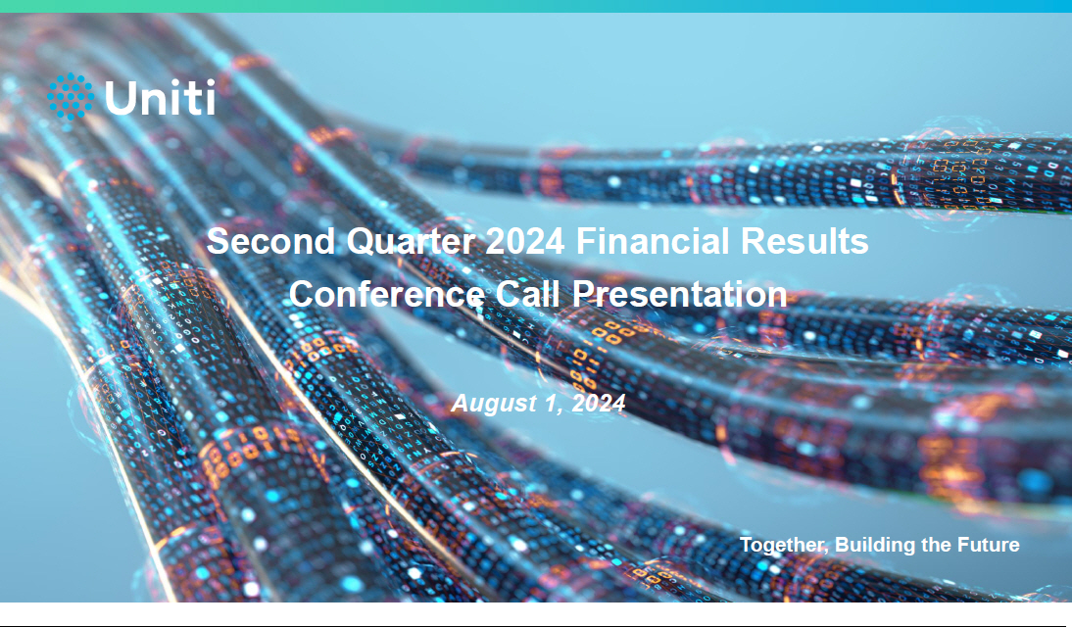

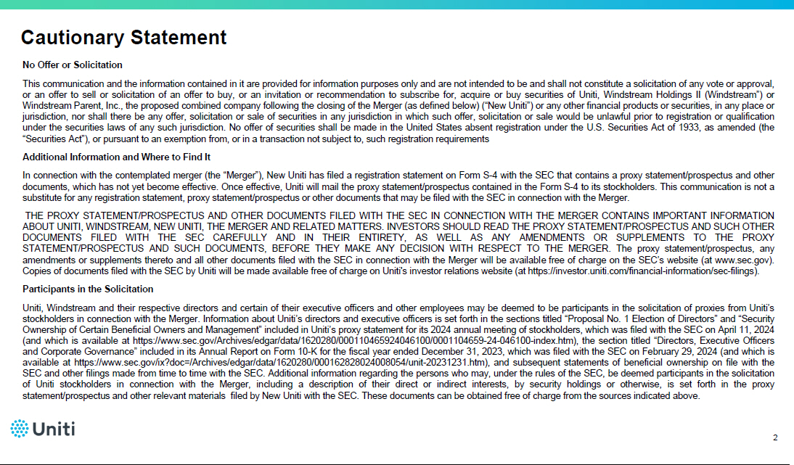

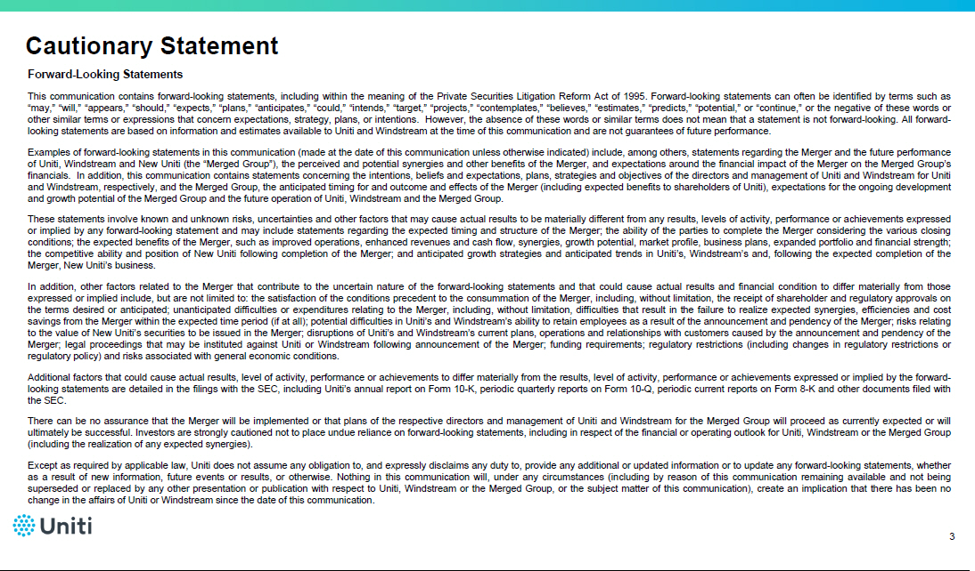

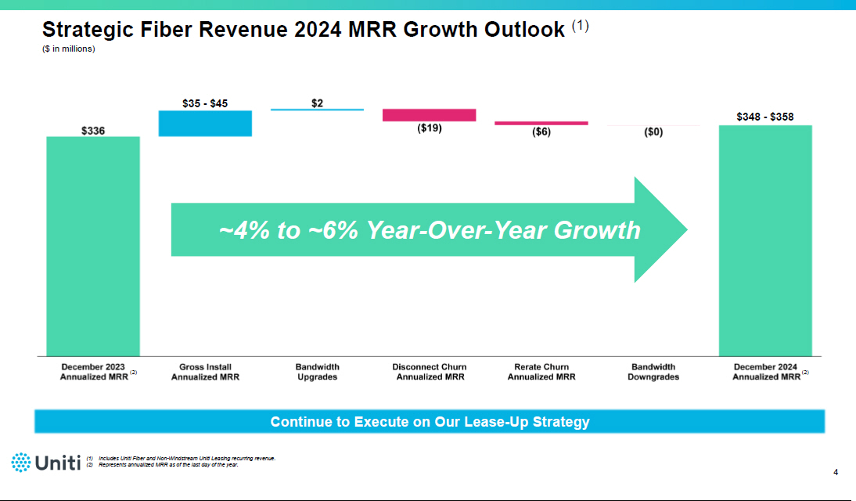

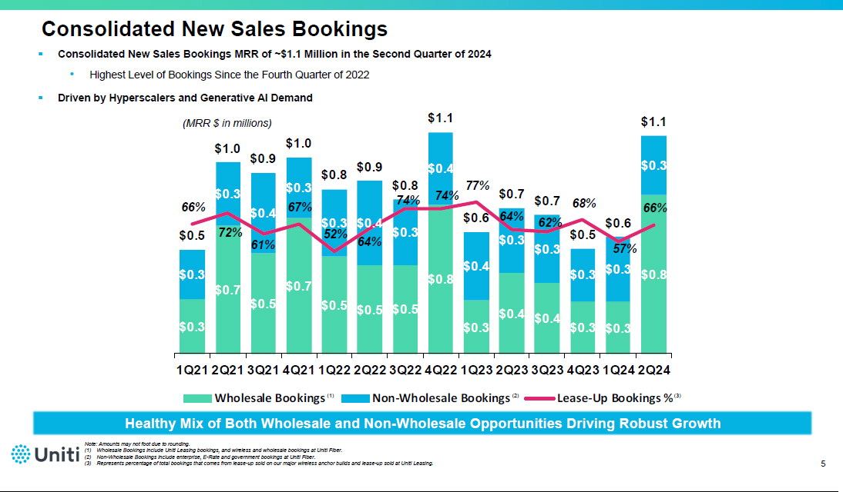

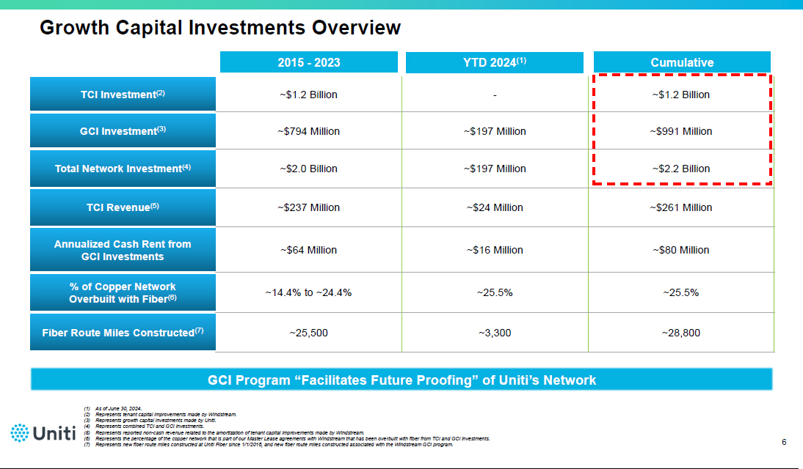

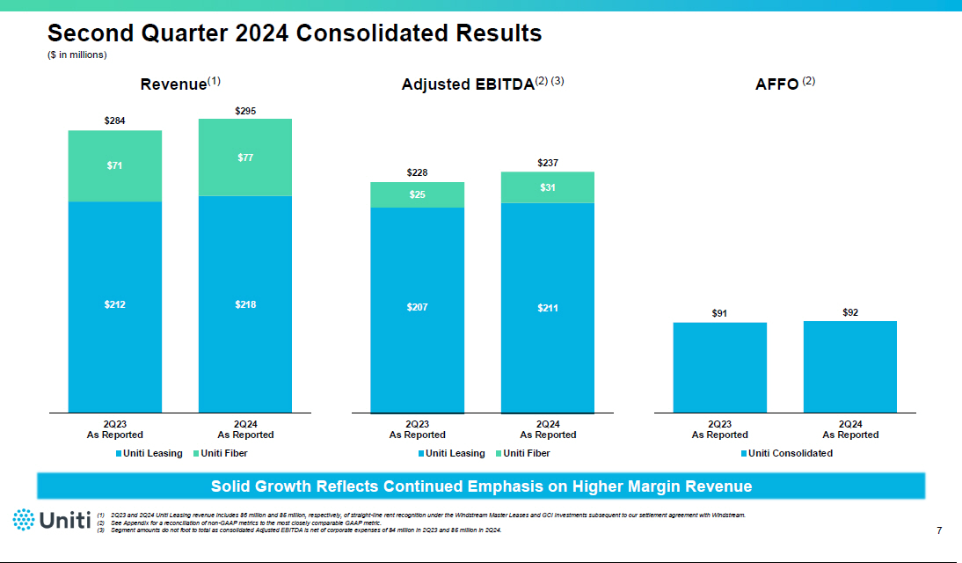

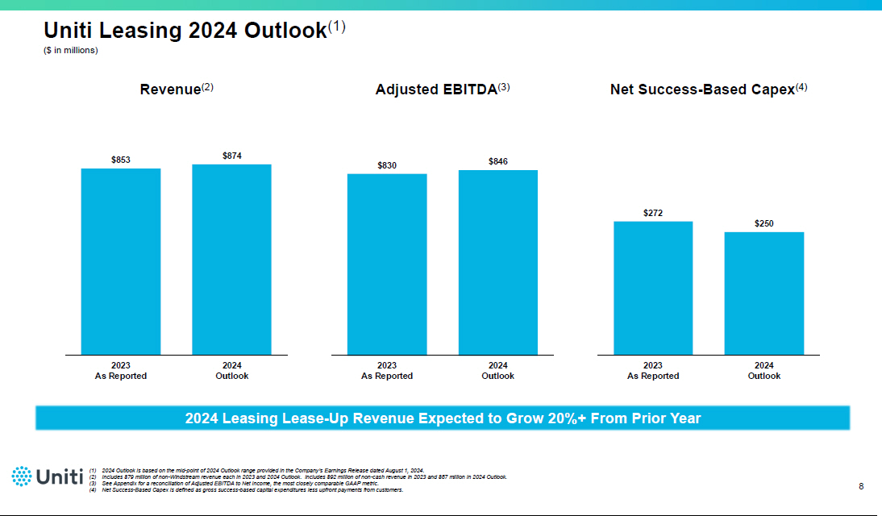

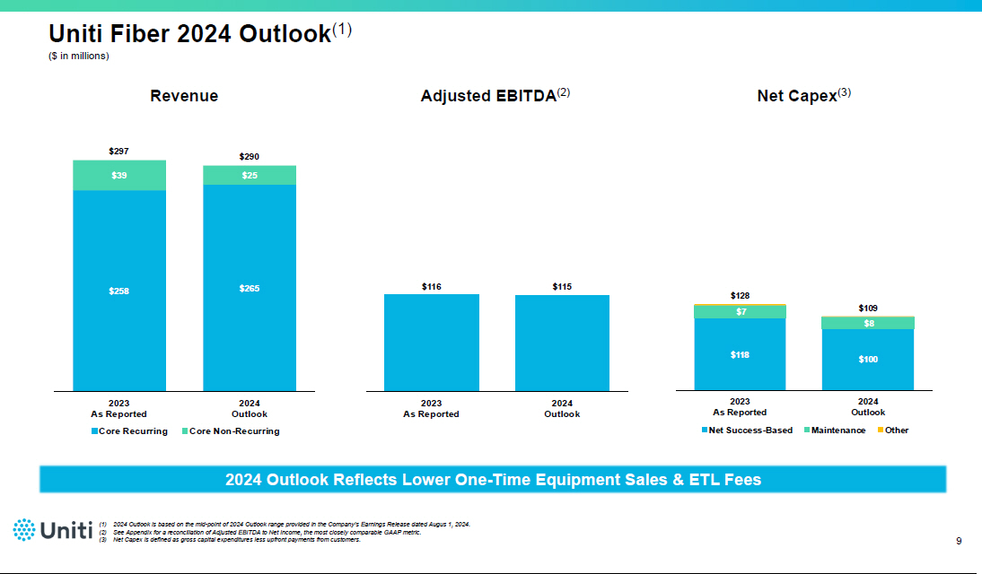

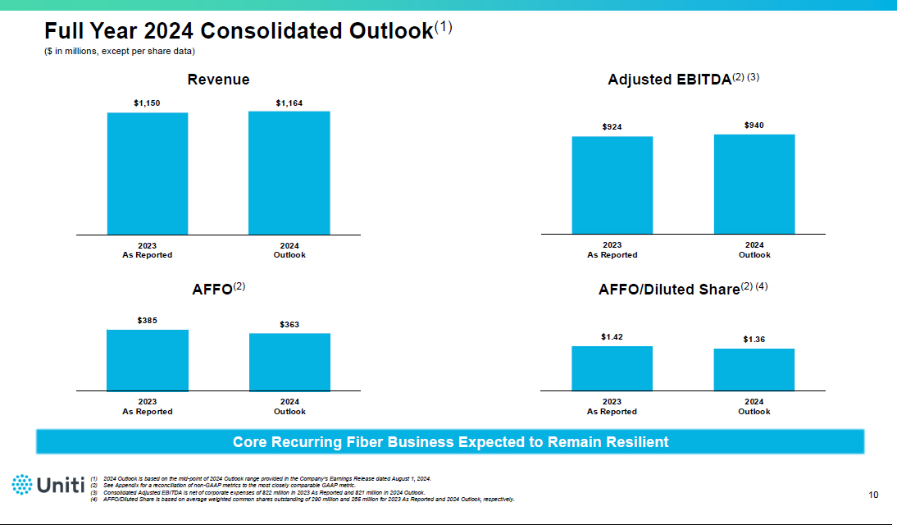

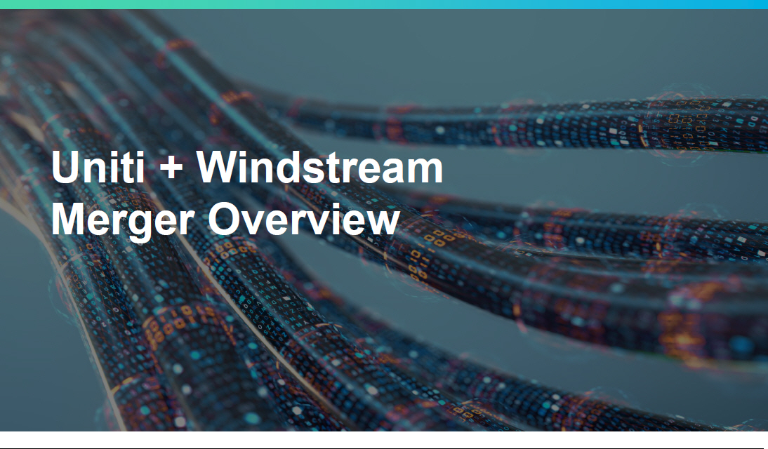

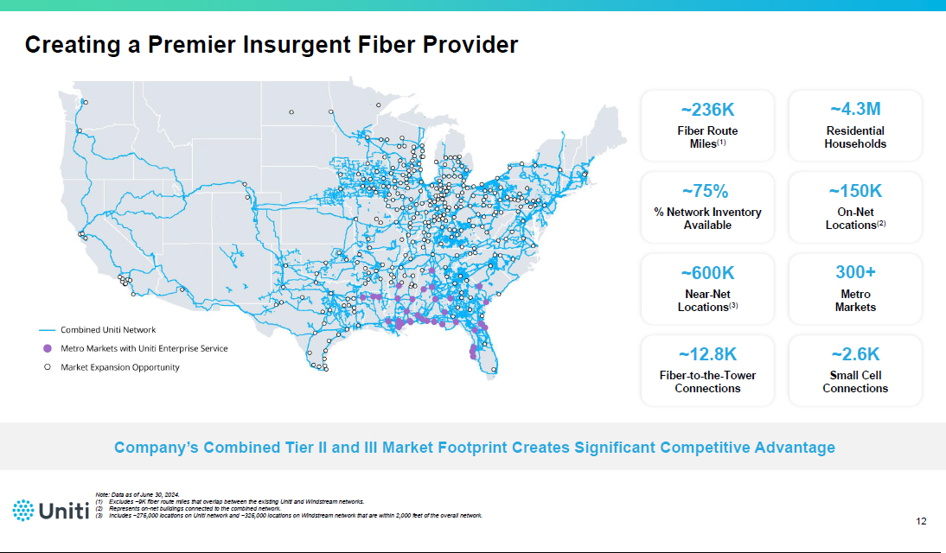

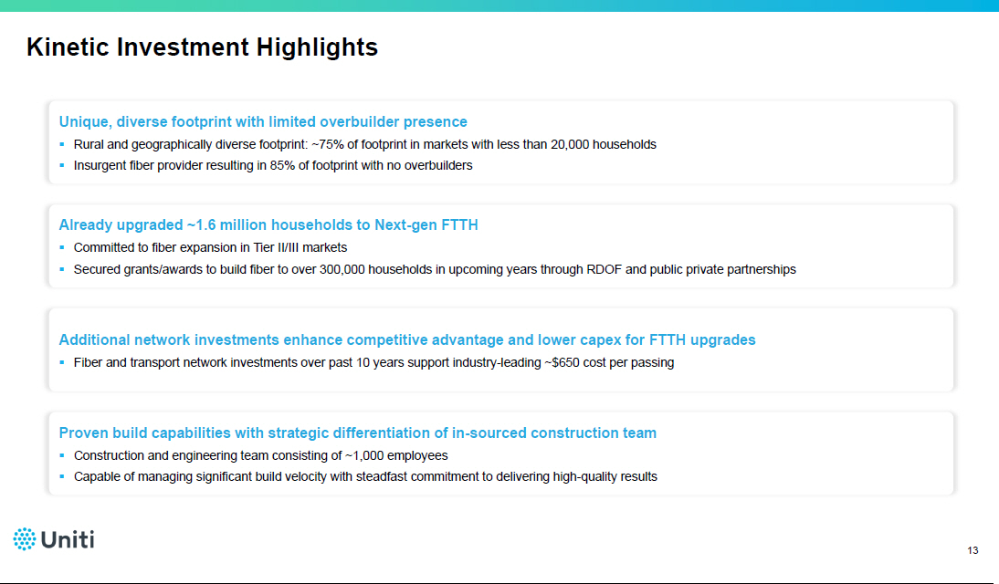

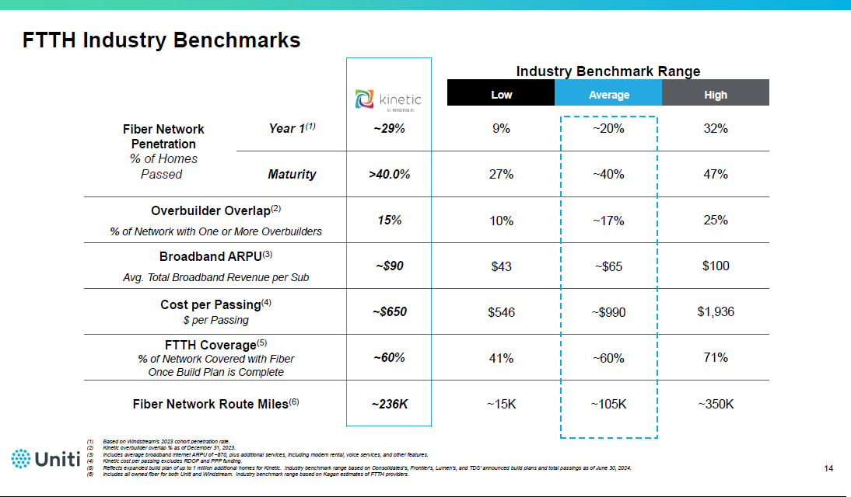

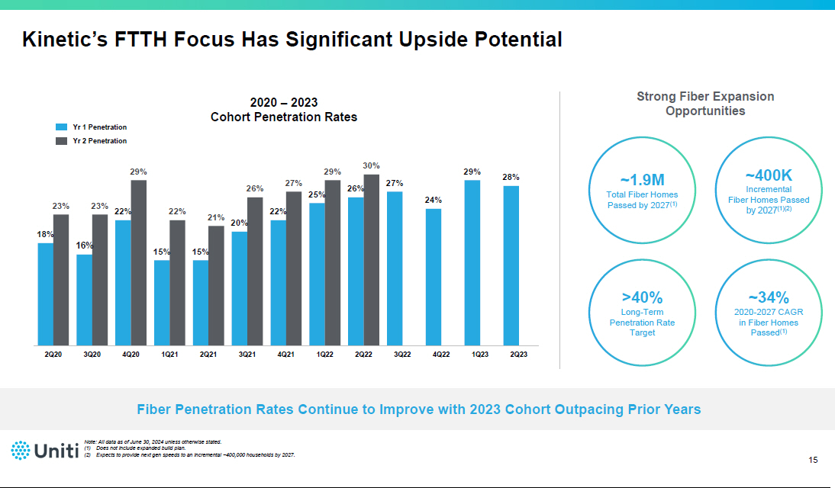

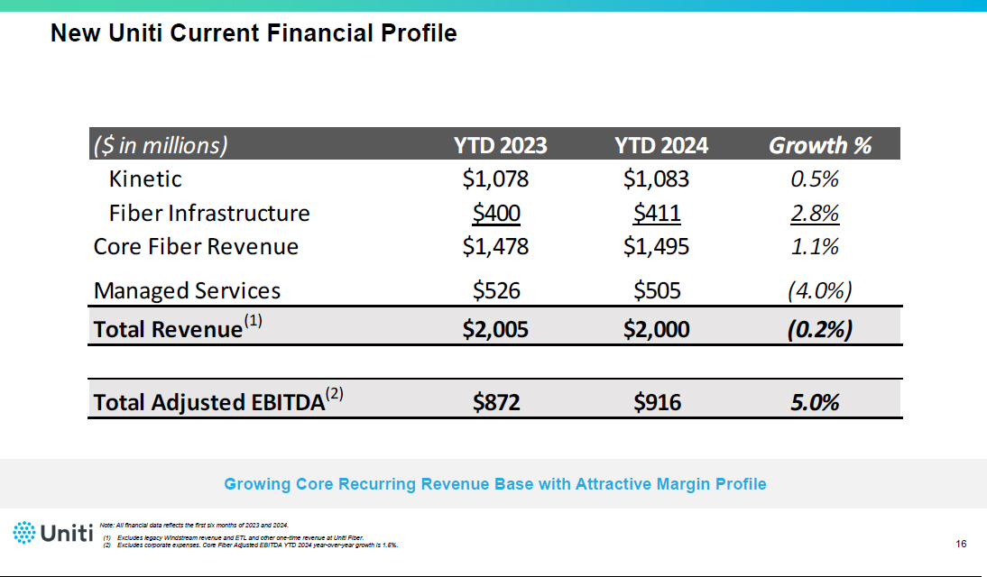

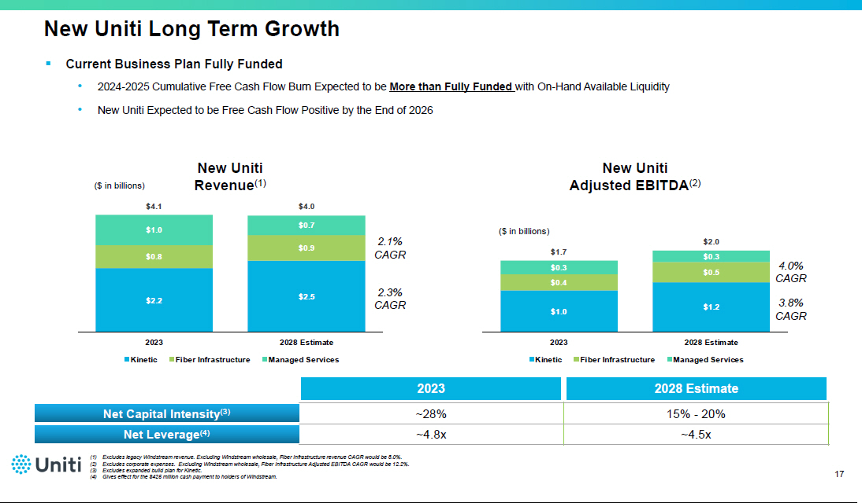

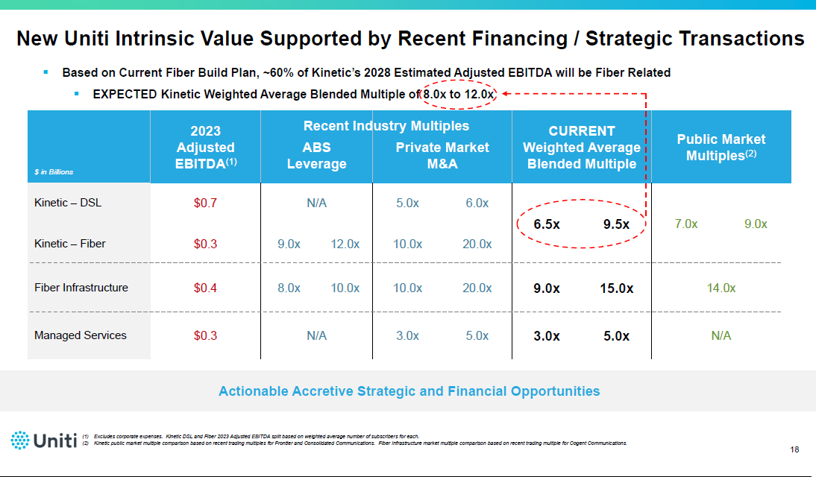

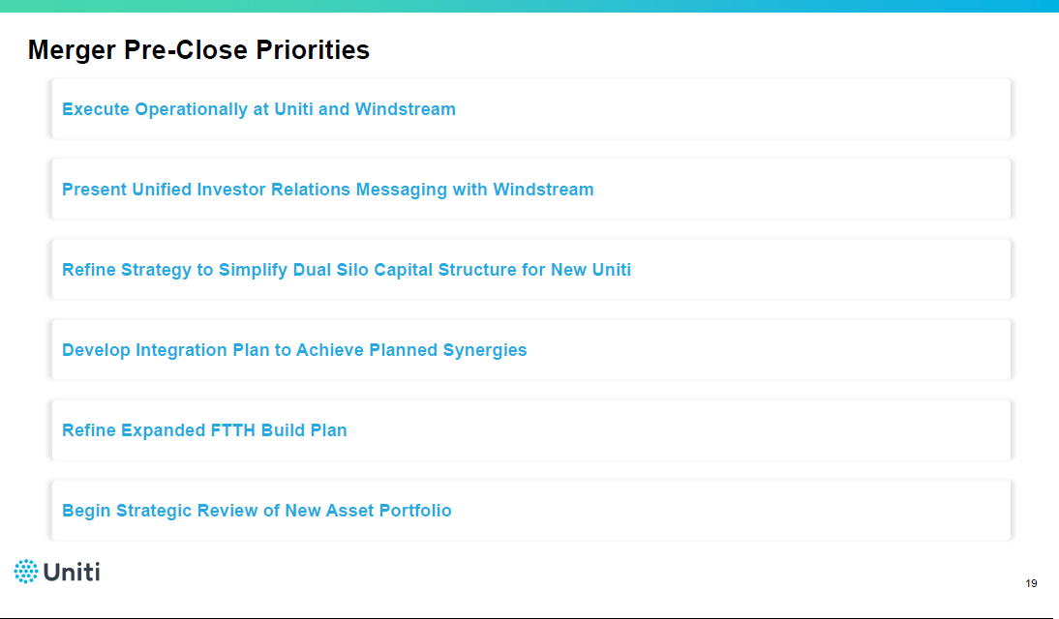

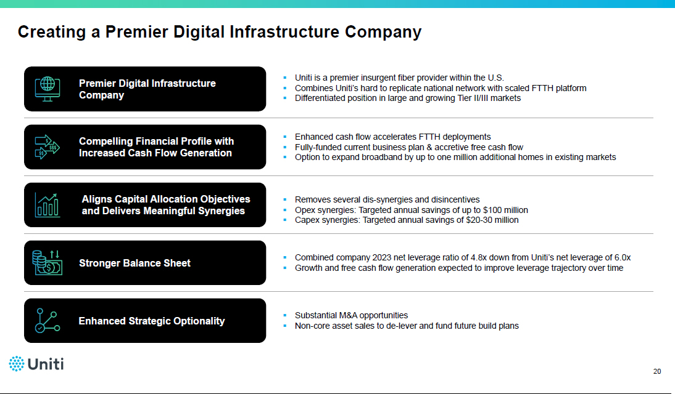

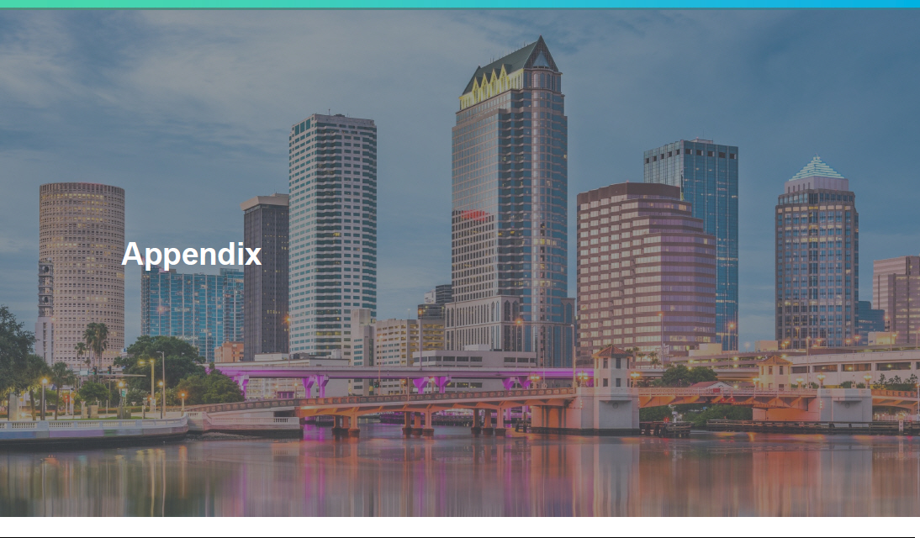

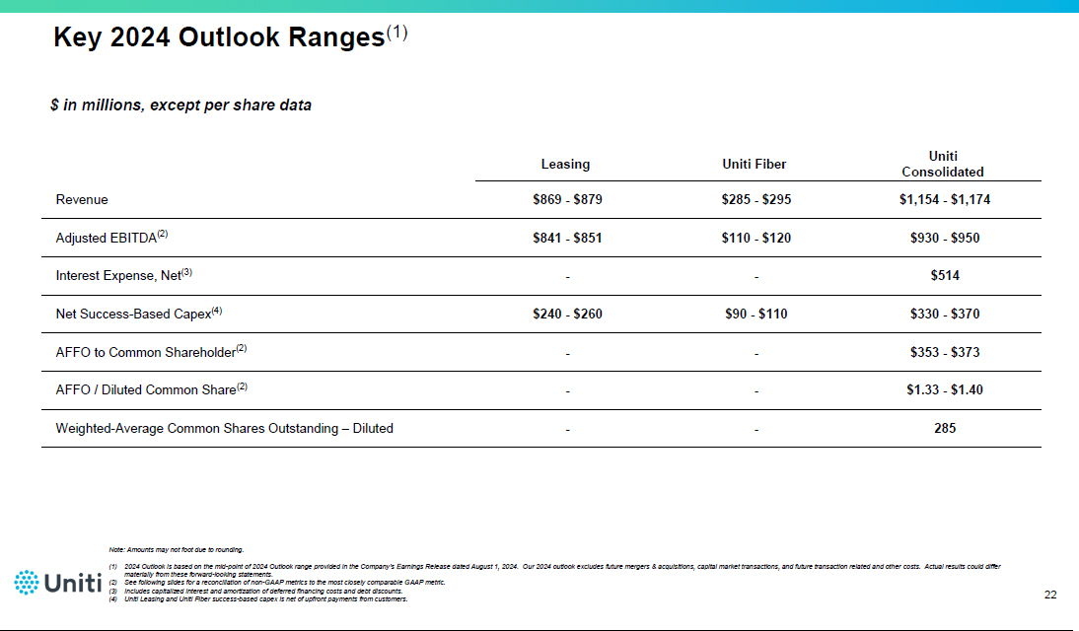

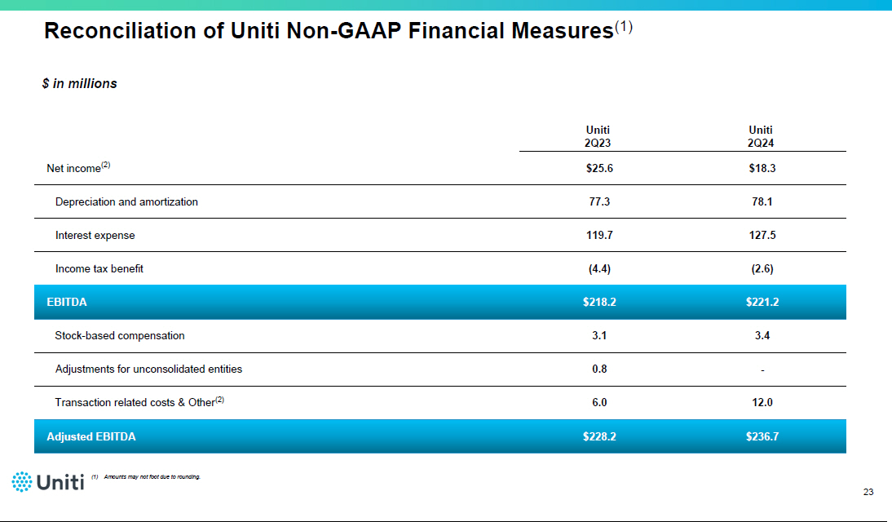

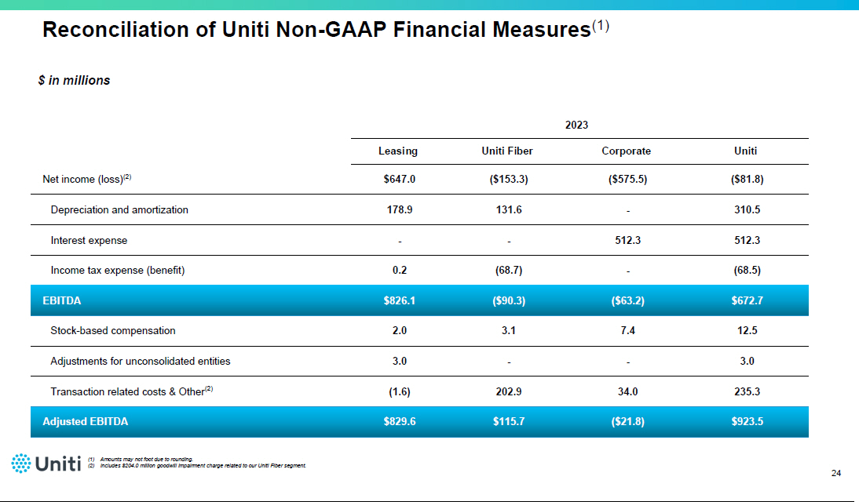

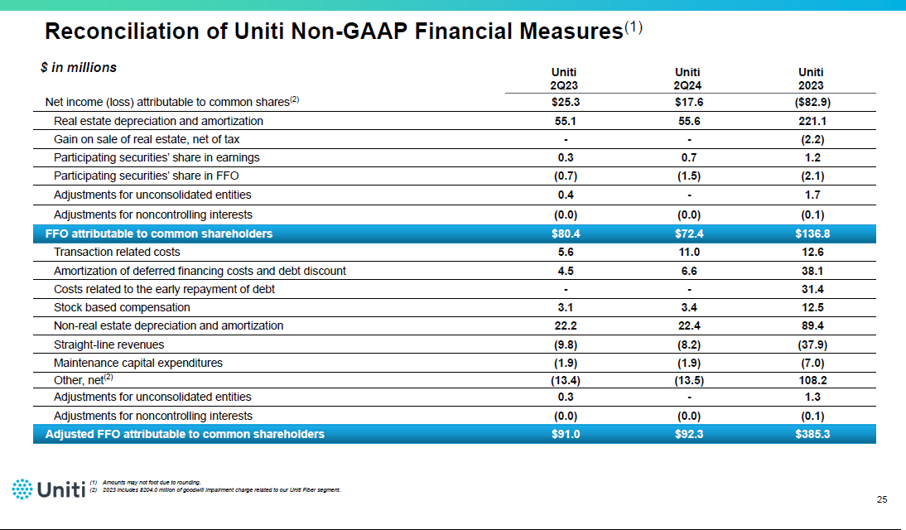

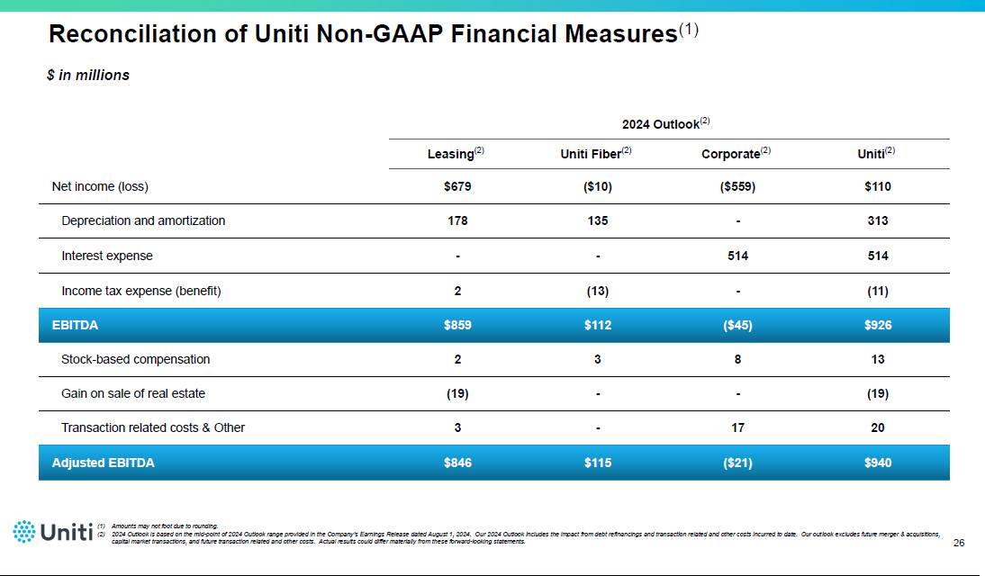

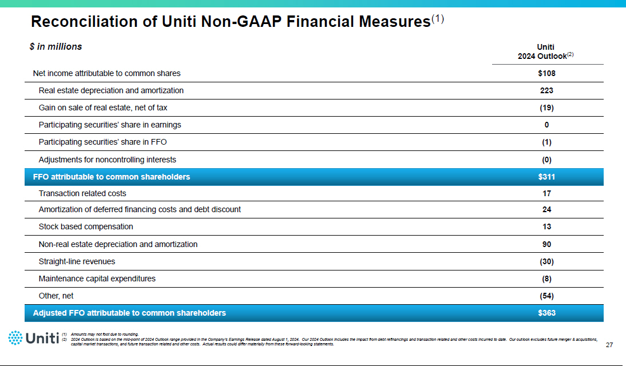

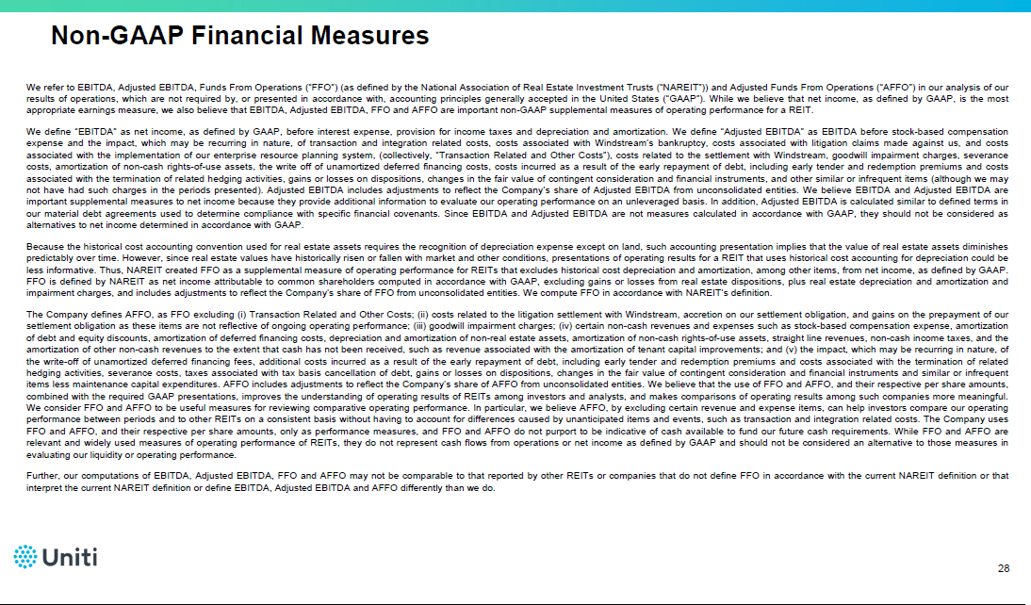

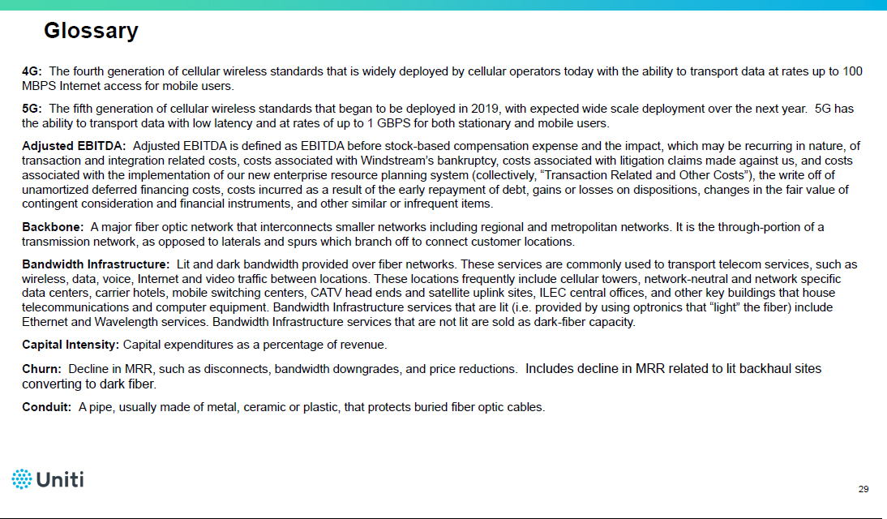

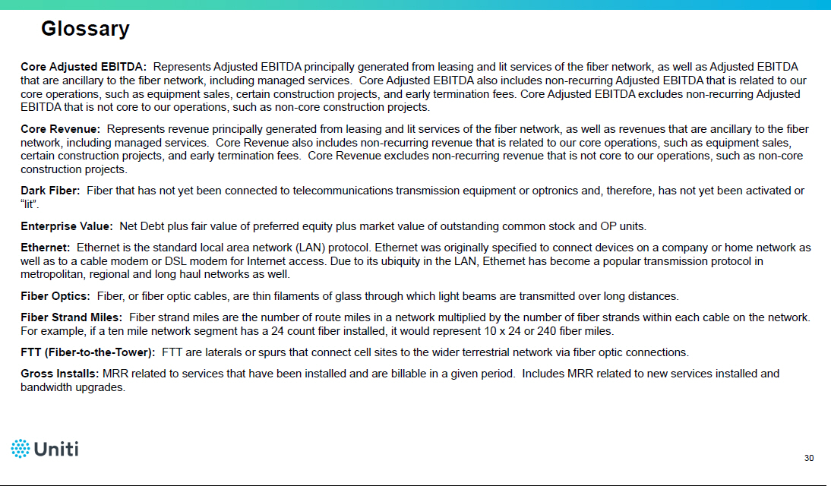

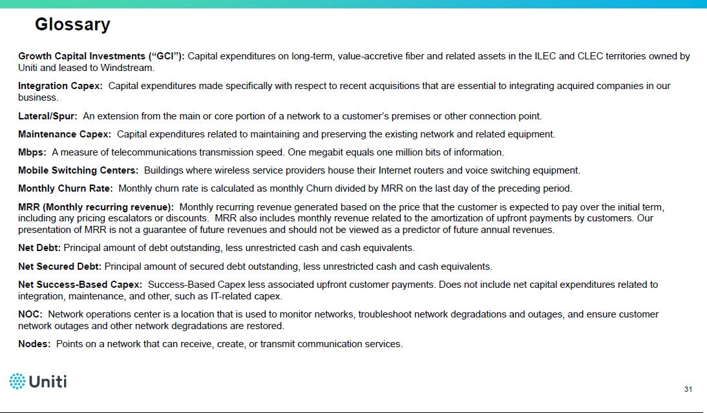

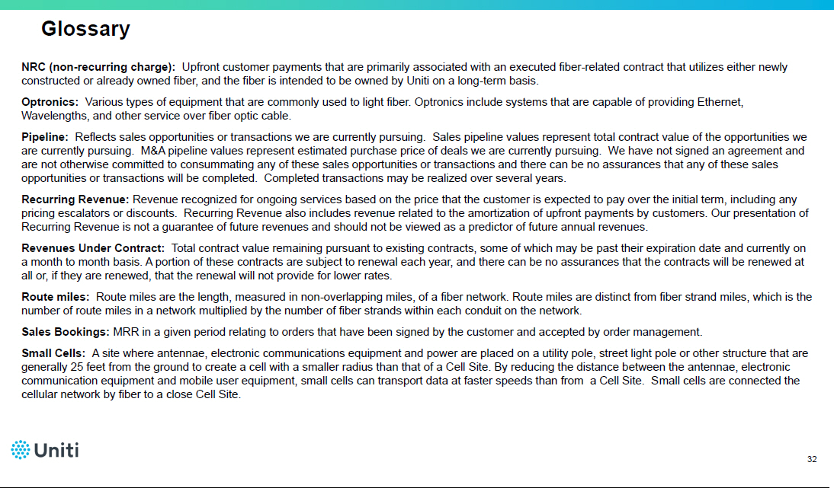

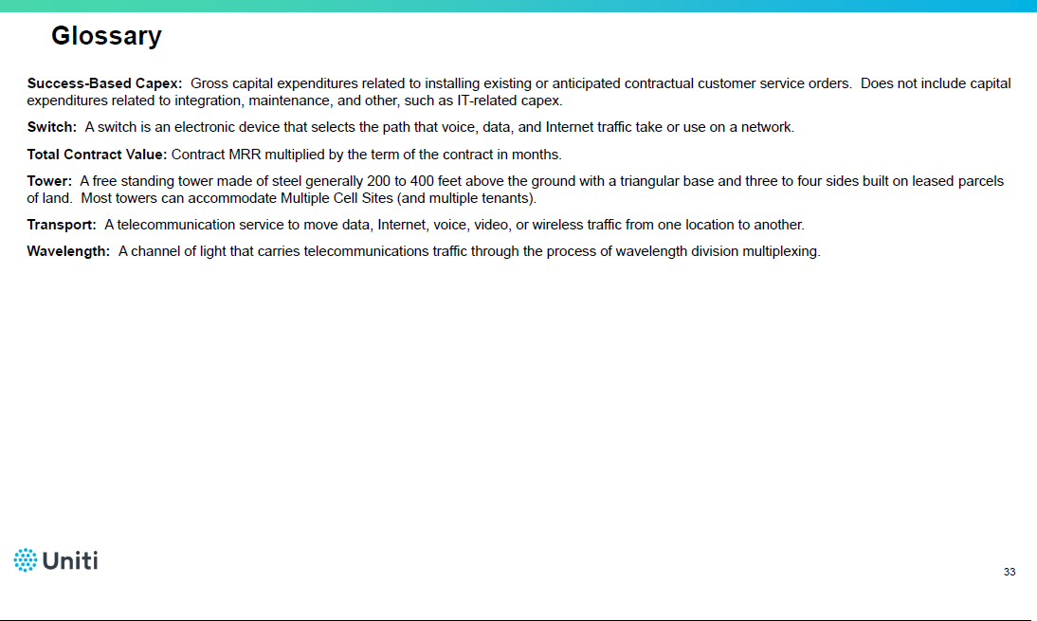

Event ID: 140507354344

Event Name: Q2 2024 Uniti Group Inc Earnings Call
Event Date: 2024-08-01T12:30:00 UTC

P: Operator;;

- Bill DiTullio;Uniti Group Inc;Vice President of Investor Relations and Treasury
- Kenneth Gunderman;Uniti Group Inc;President, Chief Executive Officer, Director
- Paul Bullington;Uniti Group Inc;Chief Financial Officer, Senior Vice President, Treasurer
- Greg Williams;TD Cowen;Analyst
- Shipra Pandey;BofA Global Research;Analyst
- Robert Palmisano;Raymond James;Analyst

+++ presentation

Operator^ Good morning and welcome to today's conference call to discuss Uniti's second-quarter 2024 earnings results. My name is Latif, and I will be your operator for today. Today's call is being recorded and a webcast will be available on the company's Investor Relations website, investor.uniti.com, beginning today and will remain available for 365 days. (Operator Instructions) It is now my pleasure to introduce Bill DiTullio, Uniti's Vice President of Investor Relations and Treasury. Please begin.

Bill DiTullio^ Good morning, everyone and thank you for joining today's conference call to discuss Uniti's second-quarter 2024 results. Speaking on the call today will be Kenny Gunderman, our CEO; and Paul Bullington, Uniti's CFO. Before we get started, I would like to quickly cover our safe harbor statement.

Please note that today's remarks may contain forward-looking statements. These statements include, but are not limited to, statements about the benefits of the proposed transaction between Uniti and Windstream, including future financial and operating results of either company or the combined company; statements related to the expected timing of the completion of the transaction and combined company plans; and other statements that are not historical facts. Any forward-looking statements contained in today's discussion and materials speak only as of the particular date or dates indicated in the materials.

Please also note that Uniti and Windstream, through the entity that will be the combined parent company following the merger, recently filed a preliminary Form S-4 registration statement with the SEC that includes a proxy statement and prospectus regarding the transaction that has not yet become effective. Investors are urged to read that proxy statement and prospectus as it contains important information about the transaction. In addition, Uniti and Windstream and their directors and officers may be deemed to be participating in the solicitation of proxies in favor of the transaction.

You may find information about Uniti directors and executive officers in the company's most recent proxy statement. You may also obtain a copy of the preliminary proxy statement and prospectus through the SEC website, Uniti's and Windstream's websites, or by requesting a copy from either company's Investor Relations website. More information on how to request these documents is available in the presentation that accompanies this call.

Uniti does not undertake any obligation to update or revise any of this information in today's remarks, whether as a result of new information, future events or otherwise. Numerous factors could cause actual results to differ materially from those described in the forward-looking statements. And for more information on those factors, please see the section titled Forward-Looking Statements in the presentation and the Risk Factors section of the recently filed preliminary Form S-4. With that, I would now like to turn the call over to Kenny.

Kenneth Gunderman^ Thanks Bill. Good morning, everyone and thank you for joining. Starting on slide 4, Uniti delivered another solid quarter of performance led by the continued strong demand for our mission critical fiber infrastructure. As a result, we are reiterating our consolidated full year 2024 revenue and adjusted EBITDA outlook.

Our core recurring strategic fiber business grew 3% in the second quarter fueled by exceptional growth in enterprise, wholesale, and dark fiber revenue of 12%, 15%, and 18%, respectively. When paired with our industry leading 0.3% churn, we remain on track to deliver 4% to 6% MRR growth for the full year.

We continue to execute well on our unique strategy of being a pure play fiber provider in Tier II and III metro markets and on inter-city routes. We believe that if you build fiber first in less competitive markets, you secure a right to win for many years into the future.

Turing to slide 5, we had a strong quarter of new bookings. As we have discussed previously, the demand from hyperscalers driven by generative AI is real and represented approximately 40% of this quarter's bookings. We are increasingly confident that this demand will be sustained as a meaningful amount of our entire wholesale sales funnel is from hyperscalers.

While wireless bookings for the quarter were muted, we continue to expect a pickup in wireless in the second half of this year. We are not only seeing a meaningful pickup in wireless RFPs, but we are also starting to have conversations about 25 gig upgrades at tower sites. Growth in mobile broadband, fixed wireless, and fiber-to-the-home connectivity are all driving substantial data traffic growth, and we do not see any of those trends dissipating.

Finally, fiber-to-the-home carriers are driving an increasing amount of demand procuring middle mile and intercity backhaul to connect their neighborhoods. The amount of bookings Uniti saw relating to fiber-to-the-home carriers increased threefold in 2023 vs. 2022, and we expect a similar level in 2024.

On a consolidated basis, our net capital intensity during the quarter was 31%, down from 44% in the same prior year period, and we believe it will continue to decline. There are a number of encouraging trends in bookings driving that capital efficiency including our continued focus on lease-up and a higher mix of hyperscaler deals that generally come with higher NRCs, and therefore better than our typical anchored yields. We also continue to see price stability especially in dark fiber sales.

Turning to slide 6, our growth capital investment program continues to provide positive results for Uniti and given our pending merger with Windstream, we wanted to highlight a few key points which I believe the market is under-appreciating. First, Kinetic and Uniti have invested a substantial amount of capital in its network, with over $2 billion invested since 2015. These historical investments include backhaul fiber and ultimately fiber to the node. In fact, prior to starting the fiber-to-the-home program in 2019, close to 100% of all broadband customers at Kinetic were already served by fiber backed DSLAMs. Each of these DSLAMs has a minimum 1 gig backhaul link to the market level central office and a minimum 10 gig link from that CO to the network core.

This historical investment helps enable Kinetic's approximate $650 fiber-to-the-home per passing cost, as we estimate that backhaul equates to roughly 20% of the total cost of building fiber-to-the-home for others. I will speak more on our pending merger shortly, but to complete our earnings discussion, I'll now turn the call over to Paul.

Paul Bullington^ Thank you, Kenny. I would like to begin by reviewing our second quarter performance, followed by an overview of our current 2024 outlook. We had another solid quarter highlighted by near-record consolidated bookings MRR of $1.1 million, 3% core recurring strategic fiber revenue growth, and declining consolidated net success-based capital intensity, which stood at 31% for the quarter.

As I'll cover in more detail in just a bit, our 2024 outlook for consolidated revenue and adjusted EBITDA remains unchanged as we expect to end the year within the previous guidance ranges provided. We have also provided Windstream's second quarter financial information in an 8-K filed with the SEC earlier this morning.

Please turn to slide 7 and I'll start with comments on our second quarter. We reported consolidated revenues of $295 million, consolidated adjusted EBITDA of $237 million, AFFO attributed to common shareholders of $92 million, and AFFO per diluted common share of $0.34.

At Uniti leasing, we reported segment revenues of $218 million and adjusted EBITDA of $211 million, representing an adjusted EBITDA margin of 97% for the quarter. During the second quarter, Uniti leasing deployed approximately $70 million towards growth capital investment initiatives, with the majority of the investments relating to the Windstream GCI program. With the GCI amount funded subsequent to the second quarter in July, Windstream has now reached its GCI funding limit for 2024 and there will be no further GCI payments for the remainder of the year.

At Uniti fiber, we reported revenues of $77 million and adjusted EBITDA of $31 million during the second quarter, achieving margins of approximately 40%. Both revenue and adjusted EBITDA during the quarter were higher than expected due to one-time non-recurring revenue items. Uniti fiber net success-based CapEx was $21 million in the second quarter. We also incurred about $2 million of maintenance CapEx during the quarter.

Please turn to slide 8, and I will now cover our updated 2024 guidance. We are revising our guidance for business unit level revisions, the recent $300 million add-on to our 10.5% secured notes, and the impact of transaction related and other costs incurred to date. Our outlook excludes the impact from the expected merger with Windstream, future acquisitions, capital market transactions, and future transaction-related and other costs not specifically mentioned herein. Actual results could differ materially from these forward-looking statements.

Our 2024 outlook for consolidated revenue and adjusted EBITDA remains unchanged. However, we are slightly increasing our Uniti fiber revenue and EBITDA to reflect the one-time revenues I referenced earlier, while slightly lowering our Uniti Leasing revenue and adjusted EBITDA estimate due to lower than expected non-cash straight-line revenue and timing of delivery on a recent lease-up award that is now expected to start billing in early 2025.

Given the expected timing of one-time sales including strategic dark fiber sales to hyperscalers, we expect second half revenue and adjusted EBITDA to be more heavily weighted in the fourth quarter vs. the third quarter. And I will point out that current consensus estimates do not reflect this expectation as third quarter estimates are currently higher than our expectations while fourth quarter estimates are lower. We are also lowering our AFFO estimate for full-year 2024 primarily due to higher interest expense related to the recent $300 million add-on to our 10.5% secured notes.

At Uniti leasing, we expect $250 million of net success-based CapEx at the midpoint of our guidance, of which approximately $ 230 million relates to Windstream GCI investments. Net success-based CapEx for Uniti fiber this year is now expected to be $100 million at the midpoint of our guidance, representing a capital intensity of 34%, down from 40% in 2023 and 45% in 2022, further demonstrating the success we are having in transitioning to less capital intensive, higher return lease-up deals.

We expect full year AFFO to range between $ 1.33 and $1.40 per diluted common share, with a mid-point of $1.36 per diluted share. As a reminder, guidance ranges for key components of our outlook are included in the appendix to our earnings presentation.

At quarter-end, we had approximately $619 million of combined unrestricted cash and cash equivalents and undrawn revolver capacity. Our leverage ratio at quarter-end was 5.97 times based on net debt to second quarter 2024 annualized Adjusted EBITDA, excluding the debt and Adjusted EBITDA impact from the ABS loan facility.

As it relates to the ABS market, we continue to view it as an attractive alternative source of financing that complements our existing capital structure well. To that end. we continue to make good progress on replacing our current ABS bridge financing with a permanent ABS solution, which we expect will be in place by later this year or early next year. With that, I'll now turn the call back over to Kenny.

Kenneth Gunderman^ Thanks Paul. As a reminder, we announced last quarter that we have reached a definitive agreement to merge Uniti and Windstream creating a national fiber powerhouse. We continue to expect the transaction to close in the second half of 2025, and we're making great progress on our timeline. In fact, we have already received 6 of 18 required PUC approvals, including Washington DC.

Given the transformative nature of this transaction, I wanted to reiterate a few key highlights. Slide 12 showcases the reach of New Uniti's insurgent fiber network, extending our successful strategy of targeting Tier II & III markets for wholesale and enterprise now into residential fiber-to-the-home. Our true north is building fiber first in less competitive markets giving us the right to win for many years into the future.

Including connected buildings, fiber-to-the-tower and small cell connections, connected POPs and data centers, and the 4.3 million total homes within Kinetic's current footprint, Uniti will have the potential to reach over 5 million connected on-ramps in largely unique locations, each driving increasing amounts of bandwidth onto our owned wholesale network.

Please turn to slide 13. Kinetic is a unique Fiber-to-the-home platform for a number of reasons. First, Fiber-to-the-home is indisputably a superior product from a latency and reliability perspective and will be for our lifetime and beyond.

Second, Incumbent providers have a big advantage when providing fiber-to-the-home given the embedded network benefiting from years of investment. And ironically, incumbents are now share takers with fiber-to-the-home after many years of playing defense against cable and wireless.

Thirdly, over 50% of Kinetic's footprint is located in the Southeast. We believe the Southeast is a terrific place to invest from a competitive and demographic point of view, as evidenced by our success at Uniti fiber. Just as importantly, 75% of Kinetic's footprint has 20,000 or fewer households, reinforcing our focus on Tier II and III markets.

Kinetic is also building fiber passings at what we believe to be an industry leading cost of $650 per passing. As I highlighted earlier, the historical GCI / TCI investments have given Kinetic a head start from a cost and network quality perspective. In addition, owning the backhaul network will also be a tool to disincentivize overbuilders from entering our markets, as in many cases our backhaul network is the only one available.

This helps segue into the final point. Only 15% of the footprint today has a true over-builder and that has held relatively constant for the last five years. We certainly don't expect this number to grow meaningfully in the future, given we are increasing our offensive posture on a combined basis.

Slide 14 highlights how Kinetic compares favorably to other providers in the industry. I've already discussed the dearth of overbuilders and the attractive cost to pass, but you can also see on this page that Kinetic compares favorably on penetration levels, ARPU, and of course the support of the expansive owned backhaul network.

Moving to slide 15, you can see Kinetic has been demonstrating strong success the past few years. Initial penetration levels on early cohorts have consistently averaged between 15% to 18% in the first year, increasing to above 25%, on average, by the second year.

Recent cohorts have been demonstrating initial penetration rates of up to 30% as Kinetic has really ramped up a more customer focused, digitally enhanced local go-to-market strategy.

As I said earlier, and as Kinetic is beginning to demonstrate, an insurgent mentality really matters and can move the needle on penetration and churn.

Windstream reported solid quarterly results yesterday, so on slide 16 we've taken the liberty of showing a consolidated year-to-date view of revenue and adjusted EBITDA for New Uniti by each segment we expect to report on post-close. Both Kinetic and Fiber infrastructure consist of a highly predictable core recurring revenue base that continues to grow and yield attractive margins.

As a reminder, our Fiber-to-the-home platform will continue to be branded as Kinetic. Fiber infrastructure will include our current Uniti fiber and Uniti leasing segments, along with the Windstream wholesale segment - all of which are highly complementary and will combine to create a premier fiber infrastructure company with both national and deep regional capabilities, and a fiber network that is predominantly owned and operated. As you can see, the core fiber business demonstrated solid top line growth for the quarter.

Managed Services is made up of Windstream's cloud-based enterprise business and is not core to our fiber infrastructure strategy. The current strategy at managed services is to focus on retaining existing customers and upselling those customers versus focusing on top line growth. This strategy has led to very stable to growing adjusted EBITDA. New Uniti intends to continue that strategy in addition to evaluating other value accretive alternatives. Importantly, on a consolidated basis, the combined business is demonstrating solid EBITDA growth.

Turning to slide 17, we expect steady, predictable top line and EBITDA growth well into the future, and the combined business should be free cash flow positive in 2026. In the meantime, our current build plan and next two years of cash burn are fully funded with on-hand or available liquidity. We believe this is another key highlight of new Uniti and gives us confidence in our long-term leverage target and our ability to generate outsized equity returns. Our fully funded plan, steady predictable results and unique hard to replicate fiber assets all suggest substantial intrinsic value in the New Uniti as highlighted on slide 18.

Recent industry valuation multiples in the ABS market, the M&A market, and publicly traded comparables all reinforce this value. Further, we recently filed the proxy statement for our transaction which includes a history of both strategic and financial interest in the combined assets of the company. The valuation metrics on this slide are further supported by those historical indications of interest.

Turning to slide 19, while the closing of the transaction is still a number of months out, we have begun and will continue to make progress on key priorities including continuing to demonstrate strong results at both companies and educating the market on the merits of the combined business. We're also using the time between now and close to actively evaluate refinancing opportunities that would allow us to collapse the dual silo capital structure. We're also actively working with Kinetic on an integration plan to achieve our synergy goals, as well as refining our fiber-to-the-home build plan to incorporate up to an additional 1 million homes. Lastly, we're never idle when it comes to M&A and with this new exciting portfolio of assets together, there is no shortage of interested counter parties with whom we are engaging.

In summary on slide 20, let me reiterate our excitement for this fantastic combination and future prospects for Uniti. We'll be a premier insurgent fiber provider in the US with a scaled platform for growth and a differentiated position in Tier II & III markets. Our enhanced balance sheet and cash flow generation will support growth, increasing our ability to expand the fiber-to-the-home builds. Looking ahead, this combination will deliver additional value accretive opportunities through meaningful synergies and M&A optionality. With that, we would be happy to take your questions.

+++ q-and-a

Operator^ (Operator Instructions) Greg Williams of TD Cowen.

Greg Williams^ Great. Thanks for taking my questions and congrats on some solid bookings here. And that's where my question is really about is, what's sort of the cadence of the deals going forward are going to see plus $1 million in bookings in many quarters going forward? I think you mentioned 40% of that is from gen AIs. Is that percentage mix going to, maybe hold as well? How many Huntsville type deals are in the funnel and for how long? Any color there would be great. Thanks.

Kenneth Gunderman^ Hey Greg, good morning. I don't think you should expect $1 million-plus quarters sequentially. I think they'll be a little lumpy. Wholesale deals are lumpy, as we've always said, including the hyperscaler deals. But I think in general, you're going to continue to see solid bookings and over the mid to longer term that's going to persist.

We're increasingly confident in the -- a more regular cadence of hyperscaler deals. And we're confident in saying that just based upon the building funnel that we have and obviously, a funnel is a leading indicator of bookings, and we've got an increasing number of opportunities in there that are -- that have been through costing and pricing have been vetted through sales engineering and vetted through grant of authority approval levels and that are at Uniti and presumably at our customers.

And so we feel good about about those opportunities. But equally importantly, when you hear what the hyperscalers say publicly about the opportunity around AI, they're extremely bullish on it. Comments ranging from there's greater risk to underinvesting than there is to overinvesting and raising CapEx guidance and materially higher CapEx related to AI next year, for example.

So I just think that we just think that the opportunity is meaningful. It will persist for some time, and we expect to achieve our -- at least our fair share of it, especially given we continue to hear a trend of the hyperscalers looking to grow into markets that have less stressed power grids and less stressed distribution grids, we're interacting more and more with our utility partners in some of these markets to talk about ways to collaborate because they also are -- that view the hyperscaler opportunity as a big one for them.

So I think we view it as a terrific opportunity and we're going to get our fair share of it. We're also going to continue pushing on all the other wholesale threads that are driving broadband growth, including wireless, including fiber-to-the-home, including traditional wholesale.

As we've said many times, we're diversified as a wholesale provider against which use case eventually is the most successful. And frankly, one of the most encouraging comments I've heard from the hyperscalers publicly recently is, that even if they don't use the infrastructure capacity that they're procuring for AI, they're going to use it for something else. And that's music to my ears because it just says there's going to be broadband growth. They're going to need this infrastructure for all manner of things, including, especially, AI. So very bullish on it, hard to predict the cadence, but the funnel is building and we're excited about the opportunity.

Greg Williams^ Got it. Thanks.

Operator^ David Barden, Bank of America.

Shipra Pandey^ Hey, hi. Thank you. This is Shipra calling in for David today. Thank you for all the details on the call. We went through the S-4, of course, it was pretty dense. So just wondering from your point of view, what in the filing on the merger are the most important pieces of information that we don't already have that we should take away from the filing. And if you could just go over the moving parts to achieving that positive free cash flow goal in 2026, particularly the CapEx outlook and how fiber extension plans might impact the current outlook. Thank you.

Kenneth Gunderman^ Good morning, Shipra. I'll take the first one and then Paul, you can take the second. I think a lot of information in there for sure pro forma financials, which obviously folks have been asking for. So I think that should be a focus area and there shouldn't be any surprises. And we look forward to engaging with the market and answering whatever questions arise from that. But we still feel very bullish and confident in the forward trajectory of the business, and Paul will comment on that as it relates to the bridge to free cash flow positive.

I think the section that really should get a lot of focus and attention is the background reading of the merger. And those are always sections that provide juicy details. But in this case, we think there's a lot of very interesting facts and circumstances in there, including number one that Uniti and really Windstream began thinking about our relationship in a much more strategic manner going back to the bankruptcy and even before. And I think when you think about the settlement and the bankruptcy and how we decided to invest materially and overbuilding the copper with fiber that was meaningful.

When you look at bifurcating the MLAs in the way we did to provide for strategic optionality and also just opening up the CLECnetwork to Uniti's use. All were very intentional and strategic in nature, which many of those things lead to a substantial amount of strategic and M&A related dialogue post the bankruptcy. And I think that's the second point that there's has been and continues to be a lot of financial and strategic interest in our collective assets and ad valuation metrics that we think are validating of what we believe the intrinsic value to be.

And while you can take a point of view on whether those multiples are -- where those multiples should be at any point in time. I think one thing that's indisputable is they validate intrinsic value, which is substantially higher than where we currently trade and where we've traded recently. So we're just very excited about the intrinsic value of the business. And I think many of the data points in that background rating validate that.

And the final point I would make is just on the background is, as you can see, we never sit on our hands when it comes to having strategic dialogue. We're regularly constantly engaging with the market. And even when transactions aren't being announced publicly, which up until recently, there hadn't been any from our perspective, we would always say that we were very active regardless, and I think that's important to note because it's hard to flip a switch off and on, on M&A, you need to stay engaged with the market. And that's always been a core tenet of ours and I think something that will persist going forward.

So Paul, you want to take --

Paul Bullington^ Yeah. Hey, Shipra, this is Paul. I'll take your second question. Yeah, so as you mentioned that, as Kenny mentioned earlier, this is a fully funded business plan to get us through the combined company plan and cash flow -- inflection to cash flow positive in 2026. Really, the piece of that are really is executing on both companies' plans as they have in place today.

Continuing to -- at Kinetic, continuing to drive fiber deeper into that business, replacing copper and hitting those marks and hitting those penetration goals for the fiber product, fiber-to-the-home product at Kinetic is going to be key. Doing that at a cost that's as projected, and that's been going really, really well. As Kenny mentioned, the cost per passing at Kinetic is coming in at $650 per home, which we think is an industry-leading number.

And so that continuing to execute on that capital plan of bringing fiber to those homes and then achieving the penetration rates that Kinetic is showing good progress toward achieving are certainly important. And then fiber infrastructure, it's really continuing to execute on just what we've been talking about, lowering capital intensity, delivering more and more lease up higher return type deals, but investment levels in that fiber infrastructure business are relatively consistent with what they are to what they are today.

And then for -- also for that Windstream business continuing to drive efficiencies, drive TDM cost out of that business which is a big part of their plan over the next couple of years, and they're making great progress with regard to doing that. We saw some nice efficiency gains and their costs this quarter, the results that were just published today in our 8-K, so some good efficiency gains in that business are continuing to drive that through.

So it's really just executing on that plan that's in front of both of our companies that we're executing on today going through the completion of that fiber-to-the-home build plan at Kinetic and kind of 2026, 2027 so it gets us to that free cash flow profile that we're talking about.

One other thing I will mention is that synergy, there's some synergy built into that as well. So we're going to have to we do our job in achieving those synergies, which we are confident that we think the $100 million kind of run rate of synergies that we've got baked into the plan are conservative and highly achievable.

Kenneth Gunderman^ Yes. And I agree with all that. I think one thing to add Shipra, is tying it back to the question about the hyperscalers. I do think that when we look at capital intensity going forward, we don't anticipate pulling back on investing in our fiber infrastructure business, as Paul mentioned. So just to be clear on that.

But I do think that there's an increasingly amount of our bigger deals whether it be anchor deals or lease of deals that have higher NRCs as a part of them, which will drive down capital intensity as I mentioned in our prepared remarks.

And I also think, independent of NRCs, there's a likelihood that we'll see higher IRU fees going forward as well. And so that -- those things are both, I'd say additions to our original plan when we think about bridging to that free cash flow period in 2026. So that's a trend that's developing and we're excited about it.

Shipra Pandey^ Thank you.

Operator^ (Operator Instructions) Frank Louthan, Raymond James.

Robert Palmisano^ Hey, guys, good morning. This is Rob on for Frank. You might have spoken to this earlier, so I didn't catch it. Are you expecting to do any builds for BEAD within Uniti fiber, not within Windstream in 2025? Or is that more likely to be a 2026 event at this point?

Kenneth Gunderman^ Morning, Rob. So we're currently not having conversations related to BEAD at Uniti. The BEAD related conversations are entirely at Kinetic, which as an aside, gives us the ability to communicate directly with Windstream about that as opposed to being competing bidders.

I do think on a combined basis, once we're -- once the transaction is closed and, on a go-forward basis, there will be opportunities to build in or around or off of our Uniti fiber network. There are some really attractive metro-fiber markets that we have as you know and taking the build and execution expertise of Kinetic and expanding that into that footprint, I think is an opportunity that we really haven't started to fully evaluate yet, but we do believe it's an opportunity that, that's on the dashboard, but that will be post-closing.

And when you look at the BEAD opportunity, we entirely agree with the way Paul -- and Paul Sunu and Drew Smith over Windstream communicated about being it's a once -- it's a terrific opportunity for Kinetic. It's really targeting the Tier II and Tier III markets where Kinetic operates and thrives today.

And so we think it's a real opportunity and it's a big part of us expanding the number of homes targeted with fiber up to 1 million. So we're really leaning into that on a combined basis, and we're excited about the opportunity that we think it's going to bring.

Robert Palmisano^ Great. Thank you, guys.

Operator^ Thank you. I would now like to turn the conference back to Kenny Gunderman for closing remarks, sir.

Kenneth Gunderman^ Great. We appreciate your interest in Uniti Group and look forward to updating you further on future calls. Thank you for joining us today.

Operator^ This concludes today's conference call. Thank you for participating. You may now disconnect.

No Offer or Solicitation

This communication and the information contained in it are provided for information purposes only and are not intended to be and shall not constitute a solicitation of any vote or approval, or an offer to sell or solicitation of an offer to buy, or an invitation or recommendation to subscribe for, acquire or buy securities of Uniti, Windstream or Windstream Parent, Inc., the proposed combined company following the closing of the Merger (as defined below) (“New Uniti”) or any other financial products or securities, in any place or jurisdiction, nor shall there be any offer, solicitation or sale of securities in any jurisdiction in which such offer, solicitation or sale would be unlawful prior to registration or qualification under the securities laws of any such jurisdiction. No offer of securities shall be made in the United States absent registration under the U.S. Securities Act of 1933, as amended (the “Securities Act”). or pursuant to an exemption from, or in a transaction not subject to, such registration requirements.

Additional Information and Where to Find It

In connection with the contemplated merger (the “Merger”), New Uniti has filed a registration statement on Form S-4 with the SEC that contains a proxy statement/prospectus and other documents, which has not yet become effective. Once effective, Uniti will mail the proxy statement/prospectus contained in the Form S-4 to its stockholders. This communication is not a substitute for any registration statement, proxy statement/prospectus or other documents that may be filed with the SEC in connection with the Merger.

THE PROXY STATEMENT/PROSPECTUS AND OTHER DOCUMENTS FILED WITH THE SEC IN CONNECTION WITH THE MERGER CONTAINS IMPORTANT INFORMATION ABOUT UNITI, WINDSTREAM, NEW UNITI, THE MERGER AND RELATED MATTERS. INVESTORS SHOULD READ THE PROXY STATEMENT/PROSPECTUS AND SUCH OTHER DOCUMENTS FILED WITH THE SEC CAREFULLY AND IN THEIR ENTIRETY, AS WELL AS ANY AMENDMENTS OR SUPPLEMENTS TO THE PROXY STATEMENT/PROSPECTUS AND SUCH DOCUMENTS, BEFORE THEY MAKE ANY DECISION WITH RESPECT TO THE MERGER. The proxy statement/prospectus, any amendments or supplements thereto and all other documents filed with the SEC in connection with the Merger will be available free of charge on the SEC’s website (at www.sec.gov). Copies of documents filed with the SEC by Uniti will be made available free of charge on Uniti's investor relations website (at https://investor.uniti.com/financial-information/sec-filings).

Participants in the Solicitation

Uniti, Windstream and their respective directors and certain of their executive officers and other employees may be deemed to be participants in the solicitation of proxies from Uniti’s stockholders in connection with the Merger. Information about Uniti’s directors and executive officers is set forth in the sections titled “Proposal No. 1 Election of Directors” and “Security Ownership of Certain Beneficial Owners and Management” included in Uniti’s proxy statement for its 2024 annual meeting of stockholders, which was filed with the SEC on April 11, 2024 (and which is available at https://www.sec.gov/Archives/edgar/data/1620280/000110465924046100/0001104659-24-046100-index.htm), the section titled “Directors, Executive Officers and Corporate Governance” included in its Annual Report on Form 10-K for the fiscal year ended December 31, 2023, which was filed with the SEC on February 29, 2024 (and which is available at https://www.sec.gov/ix? doc=/Archives/edgar/data/1620280/000162828024008054/unit-20231231.htm), and subsequent statements of beneficial ownership on file with the SEC and other filings made from time to time with the SEC. Additional information regarding the persons who may, under the rules of the SEC, be deemed participants in the solicitation of Uniti stockholders in connection with the Merger, including a description of their direct or indirect interests, by security holdings or otherwise, is set forth in the proxy statement/prospectus and other relevant materials filed by New Uniti with the SEC. These documents can be obtained free of charge from the sources indicated above.

Forward-Looking Statements

This communication contains forward-looking statements, including within the meaning of the Private Securities Litigation Reform Act of 1995. Forward-looking statements can often be identified by terms such as “may,” “will,” “appears,” “should,” “expects,” “plans,” “anticipates,” “could,” “intends,” “target,” “projects,” “contemplates,” “believes,” “estimates,” “predicts,” “potential,” or “continue,” or the negative of these words or other similar terms or expressions that concern expectations, strategy, plans, or intentions. However, the absence of these words or similar terms does not mean that a statement is not forward-looking. All forward-looking statements are based on information and estimates available to Uniti and Windstream at the time of this communication and are not guarantees of future performance.

Examples of forward-looking statements in this communication (made at the date of this communication unless otherwise indicated) include, among others, statements regarding the Merger and the future performance of Uniti, Windstream and New Uniti (the “Merged Group”), the perceived and potential synergies and other benefits of the Merger, and expectations around the financial impact of the Merger on the Merged Group’s financials. In addition, this communication contains statements concerning the intentions, beliefs and expectations, plans, strategies and objectives of the directors and management of Uniti and Windstream for Uniti and Windstream, respectively, and the Merged Group, the anticipated timing for and outcome and effects of the Merger (including expected benefits to shareholders of Uniti), expectations for the ongoing development and growth potential of the Merged Group and the future operation of Uniti, Windstream and the Merged Group.

These statements involve known and unknown risks, uncertainties and other factors that may cause actual results to be materially different from any results, levels of activity, performance or achievements expressed or implied by any forward-looking statement and may include statements regarding the expected timing and structure of the Merger; the ability of the parties to complete the Merger considering the various closing conditions; the expected benefits of the Merger, such as improved operations, enhanced revenues and cash flow, synergies, growth potential, market profile, business plans, expanded portfolio and financial strength; the competitive ability and position of New Uniti following completion of the Merger; and anticipated growth strategies and anticipated trends in Uniti’s, Windstream’s and, following the expected completion of the Merger, New Uniti’s business.

In addition, other factors related to the Merger that contribute to the uncertain nature of the forward-looking statements and that could cause actual results and financial condition to differ materially from those expressed or implied include, but are not limited to: the satisfaction of the conditions precedent to the consummation of the Merger, including, without limitation, the receipt of shareholder and regulatory approvals on the terms desired or anticipated; unanticipated difficulties or expenditures relating to the Merger, including, without limitation, difficulties that result in the failure to realize expected synergies, efficiencies and cost savings from the Merger within the expected time period (if at all); potential difficulties in Uniti’s and Windstream’s ability to retain employees as a result of the announcement and pendency of the Merger; risks relating to the value of New Uniti’s securities to be issued in the Merger; disruptions of Uniti’s and Windstream’s current plans, operations and relationships with customers caused by the announcement and pendency of the Merger; legal proceedings that may be instituted against Uniti or Windstream following announcement of the Merger; funding requirements; regulatory restrictions (including changes in regulatory restrictions or regulatory policy) and risks associated with general economic conditions.

Additional factors that could cause actual results, level of activity, performance or achievements to differ materially from the results, level of activity, performance or achievements expressed or implied by the forward-looking statements are detailed in the filings with the SEC, including Uniti’s annual report on Form 10-K, periodic quarterly reports on Form 10-Q, periodic current reports on Form 8-K and other documents filed with the SEC.

There can be no assurance that the Merger will be implemented or that plans of the respective directors and management of Uniti and Windstream for the Merged Group will proceed as currently expected or will ultimately be successful. Investors are strongly cautioned not to place undue reliance on forward-looking statements, including in respect of the financial or operating outlook for Uniti, Windstream or the Merged Group (including the realization of any expected synergies).

Except as required by applicable law, Uniti does not assume any obligation to, and expressly disclaims any duty to, provide any additional or updated information or to update any forward-looking statements, whether as a result of new information, future events or results, or otherwise. Nothing in this communication will, under any circumstances (including by reason of this communication remaining available and not being superseded or replaced by any other presentation or publication with respect to Uniti, Windstream or the Merged Group, or the subject matter of this communication), create an implication that there has been no change in the affairs of Uniti or Windstream since the date of this communication.

