UNITED STATES

SECURITIES AND EXCHANGE COMMISSION

Washington, D.C. 20549

FORM 8-K

CURRENT REPORT

Pursuant to Section 13 or 15(d)

of the Securities Exchange Act of 1934

Date of Report (Date of earliest event reported): February 21, 2025

Uniti Group Inc.

(Exact name of registrant as specified in its charter)

Maryland | 001-36708 | 46-5230630
(State or other jurisdiction | (Commission | (IRS Employer
of incorporation) | File Number) | Identification No.)
 | 2101 Riverfront Drive, Suite A
 | Little Rock, AR, 72202
 | (Address of Principal Executive Offices)
 | Registrant’s telephone number, including area code: (501) 850-0820
 | Not Applicable
 | (Former name or former address, if changed since last report.)

Check the appropriate box below if the Form 8-K filing is intended to simultaneously satisfy the filing obligation of the registrant under any of the following provisions:

- Written communications pursuant to Rule 425 under the Securities Act (17 CFR 230.425)

- Soliciting material pursuant to Rule 14a-12 under the Exchange Act (17 CFR 240.14a-12)

- Pre-commencement communications pursuant to Rule 14d-2(b) under the Exchange Act (17 CFR 240.14d-2(b))

- Pre-commencement communications pursuant to Rule 13e-4(c) under the Exchange Act (17 CFR 240.13e-4(c)) Securities registered pursuant to Section 12(b) of the Act:
Title of each class | Trading Symbol(s) | Name of each exchange on which
 |  | registered
Common Stock | UNIT | The NASDAQ Global Select Market

Indicate by check mark whether the registrant is an emerging growth company as defined in Rule 405 of the Securities Act of 1933 (§230.405 of this chapter) or Rule 12b-2 of the Securities Exchange Act of 1934 (§240.12b-2 of this chapter).

Emerging growth company ☐

If an emerging growth company, indicate by check mark if the registrant has elected not to use the extended transition period for complying with any new or revised financial accounting standards provided pursuant to Section 13(a) of the Exchange Act. ☐

Item 2.02 Results of Operations and Financial Condition

On February 21, 2025, Uniti Group Inc. (the “Company”) issued a press release announcing the Company’s results for its fiscal quarter and year ended December 31, 2024. A copy of the Company’s press release is attached to this Current Report on Form 8-K as Exhibit 99.1 and is incorporated herein solely for purposes of this Item 2.02 disclosure.

Item 7.01 Regulation FD Disclosure

The Company is furnishing certain financial and other information of Windstream Holdings II, LLC, successor in interest to Windstream Holdings, Inc., and its consolidated subsidiaries (collectively, “Windstream”) regarding the period ended December 31, 2024 as Exhibit 99.2 and Exhibit 99.3. The information furnished herein was provided to the Company by Windstream; the Company did not assist in the preparation or review of this information and makes no representation as to its accuracy.

***

The information contained in Items 2.02 and 7.01, including the exhibits attached hereto, are being “furnished” and shall not be deemed “filed” for purposes of Section 18 of the Exchange Act, or otherwise subject to the liabilities of Section 18 of the Exchange Act. The information in Items 2.02 and 7.01, including the exhibits attached hereto, shall not be incorporated by reference into any registration statement or other document pursuant to the Securities Act of 1933, as amended (the “Securities Act”), or into any filing or other document pursuant to the Exchange Act, except as otherwise expressly stated in any such filing.

No Offer or Solicitation

This communication and the information contained in it are provided for information purposes only and are not intended to be and shall not constitute a solicitation of any vote or approval, or an offer to sell or solicitation of an offer to buy, or an invitation or recommendation to subscribe for, acquire or buy securities of the Company, Windstream or Windstream Parent, Inc., the proposed combined company following the closing of the Merger (as defined below) (“New Uniti”) or any other financial products or securities, in any place or jurisdiction, nor shall there be any offer, solicitation or sale of securities in any jurisdiction in which such offer, solicitation or sale would be unlawful prior to registration or qualification under the securities laws of any such jurisdiction. No offer of securities shall be made in the United States absent registration under the Securities Act. or pursuant to an exemption from, or in a transaction not subject to, such registration requirements.

Additional Information and Where to Find It

In connection with the contemplated merger (the “Merger”), New Uniti has filed a registration statement on Form S-4 with the SEC, as amended (No. 333-281068), which was declared effective by the SEC on February 12, 2025 and contains a definitive proxy statement/prospectus and other documents. The definitive proxy statement/prospectus was mailed to stockholders of the Company seeking their approval of the transaction-related proposals. This communication is not a substitute for any registration statement, proxy statement/prospectus or other documents that have been or may be filed with the SEC in connection with the Merger.

THE DEFINITIVE PROXY STATEMENT/PROSPECTUS AND OTHER DOCUMENTS FILED WITH THE SEC IN CONNECTION WITH THE MERGER CONTAINS IMPORTANT INFORMATION ABOUT THE COMPANY, WINDSTREAM, NEW UNITI, THE MERGER AND RELATED MATTERS. INVESTORS SHOULD READ THE DEFINITIVE PROXY STATEMENT/PROSPECTUS AND SUCH OTHER DOCUMENTS FILED WITH THE SEC, AS WELL AS ANY SUPPLEMENTS THERETO, CAREFULLY AND IN THEIR ENTIRETY, BEFORE THEY MAKE ANY DECISION WITH RESPECT TO THE MERGER. The definitive proxy statement/prospectus, any supplements thereto and all other documents filed with the SEC in connection with the Merger are available free of charge on the SEC’s website (at www.sec.gov). Copies of documents filed with the SEC by the Company have been and will continue to be made available free of charge on the Company's investor relations website (at https://investor.uniti.com/financial-information/sec-filings).

Participants in the Solicitation

The Company, Windstream and their respective directors and certain of their executive officers and other employees may be deemed to be participants in the solicitation of proxies from the Company’s stockholders in connection with the Merger. Information about the Company’s directors and executive officers is set forth in the sections titled “Proposal No. 1 Election of Directors” and “Security Ownership of Certain Beneficial Owners and Management” included in the Company’s proxy statement for its 2024 annual meeting of stockholders, which was filed with the SEC on April 11, 2024 (and which is available at https://www.sec.gov/Archives/edgar/data/1620280/000110465924046100/0001104659-24-046100-index.htm), the section titled “Directors, Executive Officers and Corporate Governance” included in its Annual Report on Form 10-K for the fiscal year ended December 31, 2023, which was filed with the SEC on February 29, 2024 (and which is available at https://www.sec.gov/ix?doc=/Archives/edgar/data/1620280/000162828024008054/unit-20231231.htm), and subsequent statements of beneficial ownership on file with the SEC and other filings made from time to time with the SEC. Additional information regarding the persons who may, under the rules of the SEC, be deemed participants in the solicitation of the Company stockholders in connection with the Merger, including a description of their direct or indirect interests, by security holdings or otherwise, is set forth in the definitive proxy statement/prospectus filed by New Uniti with the SEC (and which is available at https://www.sec.gov/Archives/edgar/data/1620280/000110465925012218/tm2412846-31_defm14a.htm) .

Forward-Looking Statements

Certain statements in this Current Report on Form 8-K may constitute forward-looking statements within the meaning of the Private Securities Litigation Reform Act of 1995, as amended from time to time. Those forward-looking statements include all statements that are not historical statements of fact, including, without limitation, our 2025 financial outlook, expectations regarding lease-up of our network, strong demand trends, business strategies, growth prospects, and statements regarding the Merger and potential synergies, potential cost savings and the future performance of New Uniti (together with Windstream and Uniti, the “Merged Group”). In addition, this communication contains statements concerning the intentions, beliefs and expectations, plans, strategies and objectives of the directors and management of Uniti and Windstream for Uniti and Windstream, respectively, and the Merged Group, the anticipated timing for and outcome and effects of the Merger (including expected benefits to shareholders of Uniti), expectations for the final capital structure, ongoing development and growth potential of the Merged Group and the future operation of Uniti, Windstream and the Merged Group.

Words such as "anticipate(s)," "expect(s)," "intend(s)," “estimate(s),” “foresee(s),” "plan(s)," "believe(s)," "may," "will," "would," "could," "should," "seek(s)," “appear(s),” “target(s),” “project(s),” “contemplate(s),” “predict(s),” “potential,” “continue(s)” and similar expressions, or the negative of these terms, are intended to identify such forward-looking statements. These statements are based on management's current expectations and beliefs and are subject to a number of risks and uncertainties that could lead to actual results differing materially from those projected, forecasted or expected. Although we believe that the assumptions underlying the forward-looking statements are reasonable, we can give no assurance that our expectations will be attained. Factors which could materially alter our expectations include, but are not limited to, the future prospects of Windstream, our largest customer; the ability and willingness of our customers to renew their leases with us upon their expiration, and the ability to reposition our properties on the same or better terms in the event of nonrenewal or in the event we replace an existing tenant; the availability of and our ability to identify suitable acquisition opportunities and our ability to acquire and lease the respective properties on favorable terms; the risk that we fail to fully realize the potential benefits of acquisitions or have difficulty integrating acquired companies; our ability to generate sufficient cash flows to service our outstanding indebtedness and fund our capital funding commitments; our ability to access debt and equity capital markets; the impact on our business or the business of our customers as a result of credit rating downgrades and fluctuating interest rates; our ability to retain our key management personnel; changes in the U.S. tax law and other state, federal or local laws, whether or not specific to real estate investment trusts; covenants in our debt agreements that may limit our operational flexibility; the possibility that we may experience equipment failures, natural disasters, cyber-attacks or terrorist attacks for which our insurance may not provide adequate coverage; other risks inherent in the communications industry and in the ownership of communications distribution systems, including potential liability relating to environmental matters and illiquidity of real estate investments; the satisfaction of the conditions precedent to the consummation of the Merger, including, without limitation, the receipt of shareholder and regulatory approvals on the terms desired or anticipated; unanticipated difficulties or expenditures relating to the Merger, including, without limitation, difficulties that result in the failure to realize expected synergies, efficiencies and cost savings from the Merger within the expected time period (if at all); potential difficulties in Uniti’s and Windstream’s ability to retain employees as a result of the announcement and pendency of the Merger; risks relating to the value of New Uniti’s securities to be issued in connection with the Merger; disruptions of Uniti’s and Windstream’s current plans, operations and relationships with customers caused by the announcement and pendency of the Merger; legal proceedings that may be instituted against Uniti or Windstream following announcement of the Merger; funding requirements; regulatory restrictions (including changes in regulatory restrictions or regulatory policy); and additional factors described in our reports filed with the SEC.

There can be no assurance that the Merger will be implemented or that plans of the respective directors and management of Uniti and Windstream for the Merged Group will proceed as currently expected or will ultimately be successful. Investors are strongly cautioned not to place undue reliance on forward-looking statements, including in respect of the financial or operating outlook for Uniti, Windstream or the Merged Group (including the realization of any potential cost savings or expected synergies). See also “Additional Information and Where to Find it.”

All forward-looking statements are based on information and estimates available at the time of this communication and are not guarantees of future performance.

Except as required by applicable law, Uniti does not assume any obligation to, and expressly disclaims any duty to, provide any additional or updated information or to update any forward-looking statements, whether as a result of new information, future events or results, or otherwise. Nothing in this communication will, under any circumstances (including by reason of this communication remaining available and not being superseded or replaced by any other presentation or publication with respect to Uniti, Windstream or the Merged Group, or the subject matter of this communication), create an implication that there has been no change in the affairs of Uniti or Windstream since the date of this communication.

Item 9.01 Financial Statements and Exhibits

(d) Exhibits
Exhibit
Number |  |  |  |  |  |  | Description
 | 99.1 |  |  | Press Release issued February 21, 2025
 | 99.2 |  |  | Windstream presentation regarding the period ended December 31, 2024
 | 99.3 |  |  | Windstream transcript regarding the period ended December 31, 2024
 | 104 |  |  | Cover Page Interactive Data File (embedded within the Inline XBRL document)

SIGNATURES

Pursuant to the requirements of the Securities Exchange Act of 1934, the registrant has duly caused this report to be signed on its behalf by the undersigned hereunto duly authorized.

Date: February 21, 2025 | UNITI GROUP INC.
 | By: /s/ Daniel L. Heard
 |  | Name: | Daniel L. Heard
 |  | Title: | Executive Vice President – General Counsel and Secretary

Exhibit 99.1


Press Release

Release date: February 21, 2025

Uniti Group Inc. Reports Fourth Quarter and Full Year 2024 Results

Recently Completed Landmark ABS Financing Provides Attractive Alternative Source of

Capital While Further Strengthening Uniti’s Balance Sheet

Provides Initial 2025 Outlook

- Net Income of $21.6 Million and $93.4 Million for the Fourth Quarter and Full Year, Respectively

- Net Income of $0.09 and $0.38 Per Diluted Common Share for the Fourth Quarter and Full Year, Respectively

- AFFO of $0.35 and $1.35 Per Diluted Common Share for the Fourth Quarter and Full Year, Respectively

LITTLE ROCK, Ark., February 21, 2025 (GLOBE NEWSWIRE) – Uniti Group Inc. (“Uniti” or the “Company”) (Nasdaq: UNIT) today announced its results for the fourth quarter and full year 2024.

“2024 was a transformational year for Uniti with the announcement of our upcoming merger with Windstream, solid growth across our business segments, and continued work to improve and strengthen our balance sheet. Our core recurring strategic fiber revenue grew approximately 5% in 2024 when compared to 2023, consolidated bookings were up 40% during the fourth quarter when compared to the same period last year, and the capital intensity of our fiber business continues to decline. Strategically, Uniti is uniquely well positioned to benefit from the emerging themes related to Generative AI and convergence, both of which put a premium demand on our mission critical fiber infrastructure,” commented President and Chief Executive Officer, Kenny Gunderman.

Mr. Gunderman continued, “Turning to our balance sheet, we continue to work diligently to enhance and strengthen our capital structure prior to completing the merger with Windstream. We recently completed our landmark inaugural ABS transaction that provides Uniti with an attractive source of capital, and used a portion of those proceeds to redeem some of our most expensive debt. Also, together with recent refinancing activity at Windstream, we have successfully pushed out a meaningful portion of the combined company’s upcoming debt maturities, specifically those that were set to mature in 2028. Finally, we continue to make meaningful progress on our merger with Windstream and remain on track to close the transaction by the second half of 2025.”

QUARTERLY RESULTS

Consolidated revenues for the fourth quarter of 2024 were $293.3 million. Net income and Adjusted EBITDA were $21.6 million and $239.5 million, respectively, for the same period, achieving Adjusted EBITDA margins of approximately 82%. Net income attributable to common shares was $21.0 million for the period. AFFO attributable to common shareholders was $92.0 million, or $0.35 per diluted common share.

1

Uniti Fiber contributed $71.7 million of revenues and $31.1 million of Adjusted EBITDA for the fourth quarter of 2024, achieving Adjusted EBITDA margins of approximately 43%.

Uniti Leasing contributed revenues of $221.7 million and Adjusted EBITDA of $214.5 million for the fourth quarter.

Combined gross capital expenditures for both Uniti Fiber and Uniti Leasing were $24.3 million during the fourth quarter of 2024, which was offset by upfront customer payments totaling $23.6 million, resulting in net success-based capex of $0.7 million for the quarter.

FULL YEAR RESULTS

Consolidated revenues for the year ended December 31, 2024 were $1.2 billion. Net income and Adjusted EBITDA were $93.4 million and $940.1 million, respectively, for the same period. Net income attributable to common shares was $91.3 million for the period. AFFO attributable to common shareholders was $358.9 million, or $1.35 per diluted common share.

Uniti Fiber contributed $286.4 million of revenues and $111.6 million of Adjusted EBITDA for the full year of 2024, achieving Adjusted EBITDA margins of approximately 39%. Uniti Fiber’s net success-based capital expenditures for the full year of 2024 were $69.3 million, representing capital intensity of 24%.

Uniti Leasing contributed revenues of $880.5 million and Adjusted EBITDA of $851.2 million for the full year of 2024. Uniti Leasing’s net success-based capital expenditures for the full year of 2024 were $242.8 million, including $230.8 million of GCI capex.

FINANCING TRANSACTIONS

On February 3, 2025, Uniti announced that it had closed on its previously announced inaugural $589 million fiber securitization notes offering (collectively, the “Series 2025-1 Term Notes”). The Series 2025-1 Term Notes have a weighted average yield of approximately 6.5% and will be secured by certain fiber network assets and related customer contracts in the State of Florida and the Gulf Coast region of Louisiana, Mississippi and Alabama.

Uniti used a portion of the net proceeds to repay and terminate its existing ABS bridge facility, and to redeem $125 million aggregate principal amount of its outstanding 10.50% senior secured notes due 2028.

LIQUIDITY

At year-end, the Company had approximately $655.6 million of unrestricted cash and cash equivalents, and undrawn borrowing availability under its revolving credit agreement. The Company’s leverage ratio at year-end was 5.80x based on net debt to fourth quarter 2024 annualized Adjusted EBITDA, excluding the debt and the net contributions from the ABS facilities.

FULL YEAR 2025 OUTLOOK

Our 2025 outlook includes the estimated impact from the recent ABS financing and partial redemption of the 10.50% senior secured notes due 2028. Our outlook excludes any impact from the expected merger with Windstream, future acquisitions, capital market transactions, and future transaction-related and other costs not mentioned herein.

2

The Company’s consolidated outlook for 2025 is as follows (in millions):
 |  |  |  |  | Full Year 2025
Revenue |  |  | $ | 1,196 | to | $ | 1,216
Net income attributable to common shareholders |  |  |  | 95 | to |  | 115
Adjusted EBITDA ⁽¹⁾ |  |  |  | 966 | to |  | 986
Interest expense, net ⁽²⁾ |  |  |  | 532 | to |  | 532
Attributable to common shareholders:
FFO ⁽¹⁾ |  |  |  | 322 | to |  | 342
AFFO ⁽¹⁾ |  |  |  | 369 | to |  | 389
Weighted-average common shares outstanding – diluted |  |  |  | 280 | to |  | 280
(1) | See “Non-GAAP Financial Measures” below.
(2) | See “Components of Interest Expense” below.

CONFERENCE CALL

Uniti will hold a conference call today to discuss this earnings release at 8:30 AM Eastern Time (7:30 AM Central Time). The conference call will be webcast live on Uniti’s Investor Relations website at investor.uniti.com. Those parties interested in participating via telephone may register on the Company’s Investor Relations website or by clicking here. A replay of the call will also be made available on the Investor Relations website.

ABOUT UNITI

Uniti, an internally managed real estate investment trust, is engaged in the acquisition and construction of mission critical communications infrastructure, and is a leading provider of fiber and other wireless solutions for the communications industry. As of December 31, 2024, Uniti owns approximately 145,000 fiber route miles, 8.8 million fiber strand miles, and other communications real estate throughout the United States. Additional information about Uniti can be found on its website at www.uniti.com.

NO OFFER OR SOLICITATION

This communication and the information contained in it are provided for information purposes only and are not intended to be and shall not constitute a solicitation of any vote or approval, or an offer to sell or solicitation of an offer to buy, or an invitation or recommendation to subscribe for, acquire or buy securities of Uniti, Windstream Holdings II (“Windstream”) or Windstream Parent, Inc., the proposed combined company following the closing of the Merger (as defined below) (“New Uniti”) or any other financial products or securities, in any place or jurisdiction, nor shall there be any offer, solicitation or sale of securities in any jurisdiction in which such offer, solicitation or sale would be unlawful prior to registration or qualification under the securities laws of any such jurisdiction. No offer of securities shall be made in the United States absent registration under the U.S. Securities Act of 1933, as amended (the “Securities Act”), or pursuant to an exemption from, or in a transaction not subject to, such registration requirements.

3

ADDITIONAL INFORMATION AND WHERE TO FIND IT

In connection with the contemplated merger (the “Merger”), New Uniti has filed a registration statement on Form S-4 with the SEC, as amended (No. 333-281068), which was declared effective by the SEC on February 12, 2025 and contains a definitive proxy statement/prospectus and other documents. The definitive proxy statement/prospectus was mailed to stockholders of Uniti seeking their approval of the transaction-related proposals. This communication is not a substitute for any registration statement, proxy statement/prospectus or other documents that have been or may be filed with the SEC in connection with the Merger.

THE DEFINITIVE PROXY STATEMENT/PROSPECTUS AND OTHER DOCUMENTS FILED WITH THE SEC IN CONNECTION WITH THE MERGER CONTAIN IMPORTANT INFORMATION ABOUT UNITI, WINDSTREAM, NEW UNITI, THE MERGER AND RELATED MATTERS. INVESTORS SHOULD READ THE DEFINITIVE PROXY STATEMENT/PROSPECTUS AND SUCH OTHER DOCUMENTS FILED WITH THE SEC, AS WELL AS ANY SUPPLEMENTS THERETO, CAREFULLY AND IN THEIR ENTIRETY BEFORE THEY MAKE ANY DECISION WITH RESPECT TO THE MERGER. The definitive proxy statement/prospectus, any supplements thereto and all other documents filed with the SEC in connection with the Merger are available free of charge on the SEC’s website (at www.sec.gov). Copies of documents filed with the SEC by Uniti have been and will continue to be made available free of charge on Uniti's investor relations website (at https://investor.uniti.com/financial-information/sec-filings).

PARTICIPANTS IN THE SOLICITATION

Uniti, Windstream and their respective directors and certain of their executive officers and other employees may be deemed to be participants in the solicitation of proxies from Uniti’s stockholders in connection with the Merger. Information about Uniti’s directors and executive officers is set forth in the sections titled “Proposal No. 1 Election of Directors” and “Security Ownership of Certain Beneficial Owners and Management” included in Uniti’s proxy statement for its 2024 annual meeting of stockholders, which was filed with the SEC on April 11, 2024 (and which is available at https://www.sec.gov/Archives/edgar/data/1620280/000110465924046100/0001104659-24-046100-index.htm), the section titled “Directors, Executive Officers and Corporate Governance” included in its Annual Report on Form 10-K for the fiscal year ended December 31, 2023, which was filed with the SEC on February 29, 2024 (and which is available at https://www.sec.gov/ix?doc=/Archives/edgar/data/1620280/000162828024008054/unit-20231231.htm), and subsequent statements of beneficial ownership on file with the SEC and other filings made from time to time with the SEC. Additional information regarding the persons who may, under the rules of the SEC, be deemed participants in the solicitation of Uniti stockholders in connection with the Merger, including a description of their direct or indirect interests, by security holdings or otherwise, is set forth in the definitive proxy statement/prospectus filed by Uniti with the SEC (and which is available at https://www.sec.gov/Archives/edgar/data/1620280/000110465925012218/tm2412846-31_defm14a.htm).

FORWARD-LOOKING STATEMENTS

Certain statements in this press release and today’s conference call may constitute forward-looking statements within the meaning of the Private Securities Litigation Reform Act of 1995, as amended from time to time. Those forward-looking statements include all statements that are not historical statements of fact, including, without limitation, our 2025 financial outlook, expectations regarding lease-up of our network, strong demand trends, business strategies, growth prospects, and statements regarding the Merger and potential synergies, potential cost savings and the future performance of New Uniti (together with Windstream and Uniti, the “Merged Group”). In addition, this communication contains statements concerning the intentions, beliefs and expectations, plans, strategies and objectives of the directors and management of Uniti and Windstream for Uniti and Windstream, respectively, and the Merged Group, the anticipated timing for and outcome and effects of the Merger (including expected benefits to shareholders of Uniti), expectations for the final capital structure, ongoing development and growth potential of the Merged Group and the future operation of Uniti, Windstream and the Merged Group.

4

Words such as "anticipate(s)," "expect(s)," "intend(s)," “estimate(s),” “foresee(s),” "plan(s)," "believe(s)," "may," "will," "would," "could," "should," "seek(s)," “appear(s),” “target(s),” “project(s),” “contemplate(s),” “predict(s),” “potential,” “continue(s)” and similar expressions, or the negative of these terms, are intended to identify such forward-looking statements. These statements are based on management's current expectations and beliefs and are subject to a number of risks and uncertainties that could lead to actual results differing materially from those projected, forecasted or expected. Although we believe that the assumptions underlying the forward-looking statements are reasonable, we can give no assurance that our expectations will be attained. Factors which could materially alter our expectations include, but are not limited to, the future prospects of Windstream, our largest customer; the ability and willingness of our customers to renew their leases with us upon their expiration, and the ability to reposition our properties on the same or better terms in the event of nonrenewal or in the event we replace an existing tenant; the availability of and our ability to identify suitable acquisition opportunities and our ability to acquire and lease the respective properties on favorable terms; the risk that we fail to fully realize the potential benefits of acquisitions or have difficulty integrating acquired companies; our ability to generate sufficient cash flows to service our outstanding indebtedness and fund our capital funding commitments; our ability to access debt and equity capital markets; the impact on our business or the business of our customers as a result of credit rating downgrades and fluctuating interest rates; our ability to retain our key management personnel; changes in the U.S. tax law and other state, federal or local laws, whether or not specific to real estate investment trusts; covenants in our debt agreements that may limit our operational flexibility; the possibility that we may experience equipment failures, natural disasters, cyber-attacks or terrorist attacks for which our insurance may not provide adequate coverage; other risks inherent in the communications industry and in the ownership of communications distribution systems, including potential liability relating to environmental matters and illiquidity of real estate investments; the satisfaction of the conditions precedent to the consummation of the Merger, including, without limitation, the receipt of shareholder and regulatory approvals on the terms desired or anticipated; unanticipated difficulties or expenditures relating to the Merger, including, without limitation, difficulties that result in the failure to realize expected synergies, efficiencies and cost savings from the Merger within the expected time period (if at all); potential difficulties in Uniti’s and Windstream’s ability to retain employees as a result of the announcement and pendency of the Merger; risks relating to the value of New Uniti’s securities to be issued in connection with the Merger; disruptions of Uniti’s and Windstream’s current plans, operations and relationships with customers caused by the announcement and pendency of the Merger; legal proceedings that may be instituted against Uniti or Windstream following announcement of the Merger; funding requirements; regulatory restrictions (including changes in regulatory restrictions or regulatory policy); and additional factors described in our reports filed with the SEC, including Uniti’s annual report on Form 10-K, periodic quarterly reports on Form 10-Q, periodic current reports on Form 8-K and other documents filed with the SEC.

There can be no assurance that the Merger will be implemented or that plans of the respective directors and management of Uniti and Windstream for the Merged Group will proceed as currently expected or will ultimately be successful. Investors are strongly cautioned not to place undue reliance on forward-looking statements, including in respect of the financial or operating outlook for Uniti, Windstream or the Merged Group (including the realization of any potential cost savings or expected synergies). See also “Additional Information and Where to Find it.”

5

All forward-looking statements are based on information and estimates available at the time of this communication and are not guarantees of future performance.

Except as required by applicable law, Uniti does not assume any obligation to, and expressly disclaims any duty to, provide any additional or updated information or to update any forward-looking statements, whether as a result of new information, future events or results, or otherwise. Nothing in this communication will, under any circumstances (including by reason of this communication remaining available and not being superseded or replaced by any other presentation or publication with respect to Uniti, Windstream or the Merged Group, or the subject matter of this communication), create an implication that there has been no change in the affairs of Uniti or Windstream since the date of this communication.

NON-GAAP PRESENTATION

This release and today’s conference call contain certain supplemental measures of performance that are not required by, or presented in accordance with, accounting principles generally accepted in the United States (“GAAP”). Such measures should not be considered as alternatives to GAAP. Further information with respect to and reconciliations of such measures to the nearest GAAP measure can be found herein.

6

Assets:

Property, plant and equipment, net

Cash and cash equivalents

Restricted cash and cash equivalents

Accounts receivable, net

Goodwill

Intangible assets, net

Straight-line revenue receivable

Operating lease right-of-use assets, net

Other assets, net

Deferred income tax assets, net

Assets held for sale

Derivative asset

Total Assets

Uniti Group Inc.

Consolidated Balance Sheets

(In thousands, except per share data)

 | December 31, 2024 |  |  | December 31, 2023
$ | 4,209,747 |  | $ | 3,982,069
 | 155,593 |  |  | 62,264
 | 28,254 |  |  | —
 | 51,418 |  |  | 46,358
 | 157,380 |  |  | 157,380
 | 275,414 |  |  | 305,115
 | 108,870 |  |  | 90,988
 | 126,791 |  |  | 125,105
 | 40,556 |  |  | 118,117
 | 128,045 |  |  | 109,128
 | — |  |  | 28,605
 | 77 |  |  | —
$ | 5,282,145 |  | $ | 5,025,129

Liabilities and Shareholders’ Deficit
Liabilities:
Accounts payable, accrued expenses and other liabilities, net | $ |  | 89,688 |  | $ | 119,340
Settlement payable |  |  | 71,785 |  |  | 163,583
Intangible liabilities, net |  |  | 145,703 |  |  | 156,397
Accrued interest payable |  |  | 143,901 |  |  | 133,683
Deferred revenue |  |  | 1,400,952 |  |  | 1,273,661
Dividends payable |  |  | 665 |  |  | 36,162
Operating lease liabilities |  |  | 80,504 |  |  | 84,404
Finance lease obligations |  |  | 17,190 |  |  | 18,110
Notes and other debt, net |  |  | 5,783,597 |  |  | 5,523,579
Liabilities held for sale |  |  | — |  |  | 331
Total liabilities |  |  | 7,733,985 |  |  | 7,509,250
Commitments and contingencies
Shareholders’ Deficit:
Preferred stock, $ 0.0001 par value, 50,000 shares authorized, no shares issued and outstanding |  |  | — |  |  | —
Common stock, $ 0.0001 par value, 500,000 shares authorized, issued
and outstanding: 237,513 shares at December 31, 2024 and 236,559 shares at December 31, 2023 |  |  | 24 |  |  | 24
Additional paid-in capital |  |  | 1,236,045 |  |  | 1,221,824
Accumulated other comprehensive loss |  |  | (634) |  |  | —
Distributions in excess of accumulated earnings |  |  | (3,687,808) |  |  | (3,708,240)
Total Uniti shareholders’ deficit |  |  | (2,452,373) |  |  | (2,486,392)
Noncontrolling interests – operating partnership units and non-voting convertible preferred stock |  |  | 533 |  |  | 2,271
Total shareholders’ deficit |  |  | (2,451,840) |  |  | (2,484,121)
Total Liabilities and Shareholders’ Deficit |  | $ | 5,282,145 |  | $ | 5,025,129
 | 7

Uniti Group Inc.

Consolidated Statements of Income (Loss)

(In thousands, except per share data)

 | Three Months Ended December 31, |  |  |  |  |  |  | Year Ended December 31,
 | 2024 |  |  | 2023 |  |  |  | 2024 |  |  | 2023
Revenues:
Uniti Leasing | $ | 221,661 |  | $ | 214,923 |  | $ | 880,490 |  | $ | 852,772
Uniti Fiber |  | 71,654 |  |  | 70,733 |  |  | 286,437 |  |  | 297,059
Total revenues |  | 293,315 |  |  | 285,656 |  |  | 1,166,927 |  |  | 1,149,831
Costs and Expenses:
Interest expense, net |  | 129,671 |  |  | 123,106 |  |  | 511,364 |  |  | 512,349
Depreciation and amortization |  | 79,948 |  |  | 79,149 |  |  | 314,810 |  |  | 310,528
General and administrative expense |  | 24,473 |  |  | 25,401 |  |  | 105,019 |  |  | 102,732
Operating expense (exclusive of depreciation, accretion and amortization) |  | 33,624 |  |  | 34,398 |  |  | 140,377 |  |  | 144,276
Transaction related and other costs |  | 7,666 |  |  | 2,806 |  |  | 38,734 |  |  | 12,611
Loss (gain) on sale of real estate |  | 46 |  |  | (740) |  |  | (18,953) |  |  | (2,164)
Goodwill impairment |  | — |  |  | — |  |  | — |  |  | 203,998
Other (income) expense, net |  | — |  |  | (2,937) |  |  | (301) |  |  | 18,386
Total costs and expenses |  | 275,428 |  |  | 261,183 |  |  | 1,091,050 |  |  | 1,302,716
Income (loss) before income taxes and equity in earnings from unconsolidated entities |  | 17,887 |  |  | 24,473 |  |  | 75,877 |  |  | (152,885)
Income tax benefit |  | (3,686) |  |  | (5,575) |  |  | (17,555) |  |  | (68,474)
Equity in earnings from unconsolidated entities |  | — |  |  | (672) |  |  | — |  |  | (2,662)
Net income (loss) |  | 21,573 |  |  | 30,720 |  |  | 93,432 |  |  | (81,749)
Net income (loss) attributable to noncontrolling interests |  | 3 |  |  | 14 |  |  | 26 |  |  | (36)
Net income (loss) attributable to shareholders |  | 21,570 |  |  | 30,706 |  |  | 93,406 |  |  | (81,713)
Participating securities’ share in earnings |  | (587) |  |  | (317) |  |  | (2,080) |  |  | (1,207)
Dividends declared on convertible preferred stock |  | (5) |  |  | (5) |  |  | (20) |  |  | (20)
Net income (loss) attributable to common shareholders | $ | 20,978 |  | $ | 30,384 |  | $ | 91,306 |  | $ | (82,940 | )
Net income (loss) attributable to common shareholders – Basic | $ | 20,978 |  | $ | 30,384 |  | $ | 91,306 |  | $ | (82,940)
Impact of if-converted dilutive securities |  | — |  |  | — |  |  | — |  |  | —
Net income (loss) attributable to common shareholders – Diluted | $ | 20,978 |  | $ | 30,384 |  | $ | 91,306 |  | $ | (82,940 | )
Weighted average number of common shares outstanding:
Basic |  | 237,495 |  |  | 236,547 |  |  | 237,306 |  |  | 236,401
Diluted |  | 237,495 |  |  | 236,547 |  |  | 237,306 |  |  | 236,401
Earnings (loss) per common share:
Basic | $ | 0.09 |  | $ | 0.13 |  | $ | 0.38 |  | $ | (0.35)
Diluted | $ | 0.09 |  | $ | 0.13 |  | $ | 0.38 |  | $ | (0.35 | )
 | 8

Uniti Group Inc.

Consolidated Statements of Cash Flows

(In thousands)

 |  | Year Ended December 31,
 |  | 2024 |  |  |  | 2023
Cash flow from operating activities:
Net income (loss) | $ |  | 93,432 |  | $ | (81,749)
Adjustments to reconcile net income (loss) to net cash provided by operating activities:
Depreciation and amortization |  |  | 314,810 |  |  | 310,528
Amortization of deferred financing costs and debt discount |  |  | 22,738 |  |  | 18,498
Loss on debt extinguishment |  |  | — |  |  | 31,187
Interest rate cap amortization |  |  | 1,489 |  |  | —
Deferred income taxes |  |  | (18,917) |  |  | (68,497)
Equity in earnings of unconsolidated entities |  |  | — |  |  | (2,662)
Distributions of cumulative earnings from unconsolidated entities |  |  | — |  |  | 3,964
Cash paid for interest rate cap |  |  | (2,200) |  |  | —
Straight-line revenues and amortization of below-market lease intangibles |  |  | (30,584) |  |  | (37,944)
Stock-based compensation |  |  | 13,508 |  |  | 12,491
Goodwill impairment |  |  | — |  |  | 203,998
(Gain) Loss on asset disposals |  |  | (872) |  |  | (573)
Gain on sale of real estate |  |  | (18,953) |  |  | (2,164)
Gain on sale of unconsolidated entity |  |  | — |  |  | (2,646)
Accretion of settlement payable |  |  | 6,224 |  |  | 10,506
Other |  |  | 2,767 |  |  | 701
Changes in assets and liabilities:
Accounts receivable |  |  | (5,060) |  |  | (3,727)
Other assets |  |  | 15,961 |  |  | 15,795
Accounts payable, accrued expenses and other liabilities |  |  | (27,648) |  |  | (54,577)
Net cash provided by operating activities |  |  | 366,695 |  |  | 353,129
Cash flow from investing activities:
Capital expenditures |  |  | (354,834) |  |  | (417,002)
Proceeds from sale of equipment |  |  | 2,397 |  |  | 3,146
Proceeds from sale of real estate, net of cash |  |  | 40,241 |  |  | 2,545
Proceeds from sale of unconsolidated entity |  |  | 40,000 |  |  | —
Net cash used in investing activities |  |  | (272,196) |  |  | (411,311)
Cash flow from financing activities:
Repayment of debt |  |  | (122,942) |  |  | (2,263,662)
Proceeds from issuance of notes |  |  | 309,000 |  |  | 2,600,000
Dividends paid |  |  | (108,455) |  |  | (107,405)
Payments of settlement payable |  |  | (98,022) |  |  | (98,022)
Borrowings under revolving credit facility |  |  | 130,000 |  |  | 506,000
Payments under revolving credit facility |  |  | (338,000) |  |  | (486,000)
Proceeds from ABS Loan Facility |  |  | 275,000 |  |  | —
Finance lease payments |  |  | (2,652) |  |  | (2,262)
Payments for financing costs |  |  | (15,778) |  |  | (26,955)
Payment for settlement of common stock warrant |  |  | — |  |  | (56)
Proceeds from termination of bond hedge option |  |  | — |  |  | 59
Costs related to the early repayment of debt |  |  | — |  |  | (44,303)
Distributions paid to noncontrolling interests |  |  | (37) |  |  | (48)
Payment for exchange of noncontrolling interest |  |  | (92) |  |  | —
Employee stock purchase program |  |  | 657 |  |  | 730
Payments related to tax withholding for stock-based compensation |  |  | (1,595) |  |  | (1,433)
Net cash provided by financing activities |  |  | 27,084 |  |  | 76,643
Net increase in cash, restricted cash and cash equivalents |  |  | 121,583 |  |  | 18,461
Cash, restricted cash and cash equivalents at beginning of period |  |  | 62,264 |  |  | 43,803
Cash, restricted cash and cash equivalents at end of period |  | $ | 183,847 |  | $ | 62,264
Non-cash investing and financing activities:
Property and equipment acquired but not yet paid | $ |  | 10,186 |  | $ | 8,798
Tenant capital improvements |  |  | 263,087 |  |  | 167,763
Sale of unconsolidated entity |  |  | — |  |  | 40,000
 | 9

Uniti Group Inc.

Reconciliation of Net Income to FFO and AFFO

(In thousands, except per share data)

 | Three Months Ended December 31, |  |  |  |  |  | Year Ended December 31,
 | 2024 |  |  | 2023 |  |  | 2024 |  |  | 2023
Net income (loss) attributable to common shareholders | $ | 20,978 |  | $ | 30,384 |  | $ | 91,306 |  | $ | (82,940)
Real estate depreciation and amortization |  | 58,504 |  |  | 56,132 |  |  | 226,419 |  |  | 221,115
Gain on sale of real estate assets, net of tax |  | 46 |  |  | (740) |  |  | (18,905) |  |  | (2,164)
Participating securities share in earnings |  | 587 |  |  | 317 |  |  | 2,080 |  |  | 1,207
Participating securities share in FFO |  | (2,178) |  |  | (766) |  |  | (6,344) |  |  | (2,064)
Real estate depreciation and amortization from unconsolidated entities |  | — |  |  | 435 |  |  | — |  |  | 1,740
Adjustments for noncontrolling interests |  | (8) |  |  | (26) |  |  | (42) |  |  | (100)
FFO attributable to common shareholders |  | 77,929 |  |  | 85,736 |  |  | 294,514 |  |  | 136,794
Transaction related and other costs |  | 7,666 |  |  | 2,806 |  |  | 38,734 |  |  | 12,611
Amortization of deferred financing costs and debt discount |  | 5,964 |  |  | 4,523 |  |  | 22,738 |  |  | 18,498
Write off of deferred financing costs and debt discount |  | — |  |  | — |  |  | — |  |  | 10,412
Gain on extinguishment of debt |  | — |  |  | — |  |  | — |  |  | (1,269)
Costs related to the early repayment of debt |  | — |  |  | — |  |  | — |  |  | 51,997
Stock based compensation |  | 3,388 |  |  | 3,083 |  |  | 13,508 |  |  | 12,491
Gain on sale of unconsolidated entity, net of tax |  | — |  |  | (2,476) |  |  | — |  |  | (2,476)
Non-real estate depreciation and amortization |  | 21,444 |  |  | 23,016 |  |  | 88,391 |  |  | 89,413
Goodwill impairment, net of tax |  | — |  |  | — |  |  | — |  |  | 151,856
Straight-line revenues and amortization of below-market lease intangibles |  | (6,226) |  |  | (9,149) |  |  | (30,584) |  |  | (37,944)
Maintenance capital expenditures |  | (2,175) |  |  | (1,624) |  |  | (8,064) |  |  | (6,962)
TCI revenue amortization |  | (13,641) |  |  | (12,339) |  |  | (50,889) |  |  | (46,967)
Other, net |  | (2,365) |  |  | (2,332) |  |  | (9,414) |  |  | (4,370)
Adjustments for equity in earnings from unconsolidated entities |  | — |  |  | 320 |  |  | — |  |  | 1,280
Adjustments for noncontrolling interests |  | (2) |  |  | (3) |  |  | (13) |  |  | (112)
AFFO attributable to common shareholders | $ | 91,982 |  | $ | 91,561 |  | $ | 358,921 |  | $ | 385,252
Reconciliation of Diluted FFO and AFFO:
FFO Attributable to common shareholders – Basic | $ | 77,929 |  | $ | 85,736 |  | $ | 294,514 |  | $ | 136,794
Impact of if-converted dilutive securities |  | 5,967 |  |  | 7,011 |  |  | 25,825 |  |  | 27,269
FFO Attributable to common shareholders – Diluted | $ | 83,896 |  | $ | 92,747 |  | $ | 320,339 |  | $ | 164,063
AFFO Attributable to common shareholders – Basic | $ | 91,982 |  | $ | 91,561 |  | $ | 358,921 |  | $ | 385,252
Impact of if-converted dilutive securities |  | 5,747 |  |  | 6,976 |  |  | 25,277 |  |  | 28,038
AFFO Attributable to common shareholders – Diluted | $ | 97,729 |  | $ | 98,537 |  | $ | 384,198 |  | $ | 413,290
Weighted average common shares used to calculate basic earnings per common share ⁽¹⁾ |  | 237,495 |  |  | 236,547 |  |  | 237,306 |  |  | 236,401
Impact of dilutive non-participating securities |  | — |  |  | — |  |  | — |  |  | —
Impact of if-converted dilutive securities |  | 42,044 |  |  | 53,401 |  |  | 48,024 |  |  | 53,701
Weighted average common shares used to calculate diluted FFO and AFFO per common share ⁽¹⁾
 |  | 279,539 |  |  | 289,948 |  |  | 285,330 |  |  | 290,102
Per diluted common share:
EPS | $ | 0.09 |  | $ | 0.13 |  | $ | 0.38 |  | $ | (0.35)
FFO | $ | 0.30 |  | $ | 0.32 |  | $ | 1.12 |  | $ | 0.57
AFFO | $ | 0.35 |  | $ | 0.34 |  | $ | 1.35 |  | $ | 1.42

- For periods in which FFO to common shareholders is a loss, the weighted average common shares used to calculate diluted FFO per common share is equal to the weighted average common shares used to calculate basic earnings per share.

10

Net income (loss)

Depreciation and amortization

Interest expense, net

Income tax benefit

EBITDA

Stock-based compensation

Transaction related and other costs

Gain on sale of real estate

Goodwill impairment

Other, net

Adjustments for equity in earnings from unconsolidated entities

Adjusted EBITDA

Uniti Group Inc.

Reconciliation of EBITDA and Adjusted EBITDA

(In thousands)

 | Three Months Ended |  |  |  |  |  | Year Ended
 | December 31, |  |  |  |  |  | December 31,
 | 2024 |  |  | 2023 |  |  | 2024 |  |  | 2023
$ | 21,573 |  | $ | 30,720 |  | $ | 93,432 |  | $ | (81,749)
 | 79,948 |  |  | 79,149 |  |  | 314,810 |  |  | 310,528
 | 129,671 |  |  | 123,106 |  |  | 511,364 |  |  | 512,349
 | (3,686) |  |  | (5,575) |  |  | (17,555) |  |  | (68,474)
$ | 227,506 |  | $ | 227,400 |  | $ | 902,051 |  | $ | 672,654
 | 3,388 |  |  | 3,083 |  |  | 13,508 |  |  | 12,491
 | 7,666 |  |  | 2,806 |  |  | 38,734 |  |  | 12,611
 | 46 |  |  | (740) |  |  | (18,953) |  |  | (2,164)
 | — |  |  | — |  |  | — |  |  | 203,998
 | 849 |  |  | (2,180) |  |  | 4,726 |  |  | 20,893
 | — |  |  | 755 |  |  | — |  |  | 3,019
$ | 239,455 |  | $ | 231,124 |  | $ | 940,066 |  | $ | 923,502

Adjusted EBITDA:
Uniti Leasing | $ | 214,460 |  | $ | 209,478 |  | $ | 851,178 |  | $ | 829,557
Uniti Fiber |  | 31,071 |  |  | 27,011 |  |  | 111,557 |  |  | 115,723
Corporate |  | (6,076) |  |  | (5,365) |  |  | (22,669) |  |  | (21,778)
 | $ | 239,455 |  | $ | 231,124 |  | $ | 940,066 |  | $ | 923,502
Annualized Adjusted EBITDA ⁽¹⁾ | $ | 939,578
As of December 31, 2024:
Total Debt ⁽²⁾ | $ | 5,603,690
Unrestricted cash and cash equivalents |  | 155,593
Net Debt | $ | 5,448,097
Net Debt/Annualized Adjusted EBITDA |  | 5.80x

- Calculated as Adjusted EBITDA for the most recently reported three-month period, excluding net contributions of $4.6 million from the ABS Loan Facility subsidiaries, multiplied by four. Annualized Adjusted EBITDA has not been prepared on a pro forma basis in accordance with Article 11 of Regulation S-X.

- Includes $17.2 million of finance leases, but excludes $77.9 million of unamortized discounts and deferred financing costs and excludes the principal balance from the $275.0 million ABS loan facility.

11

Uniti Group Inc.
Projected Future Results ⁽¹⁾
(In millions)

Net income attributable to common shareholders

Participating securities’ share in earnings
Net income ⁽²⁾
Interest expense, net ⁽³⁾
Depreciation and amortization

Income tax benefit
EBITDA ⁽²⁾
Stock-based compensation
Transaction related and other costs ⁽⁴⁾
Adjusted EBITDA ⁽²⁾

Year Ended

December 31, 2025

$ 95 to $ 115

3

98 to 118

532

323

(4)

949 to 969

14

3

$ 966 to $ 986

- These ranges represent management’s best estimates based on the underlying assumptions as of the date of this press release. Future acquisitions, capital market transactions, changes in market conditions, and other factors are excluded from our projections. There can be no assurance that our actual results will not differ materially from the estimates set forth above.

- The components of projected future results may not add due to rounding.

- See “Components of Projected Interest Expense” below.

- Future transaction related costs not mentioned herein are not included in our current outlook.

12

 | Uniti Group Inc.
 | Projected Future Results ⁽¹⁾
 | (Per Diluted Share)
 |  | Year Ended
 |  | December 31, 2025
Net income attributable to common shareholders – Basic |  | $ 0.40 to $ 0.48
Real estate depreciation and amortization | 0.98
Participating securities’ share in earnings and FFO, net |  | (0.03)
FFO attributable to common shareholders – Basic ⁽²⁾
FFO attributable to common shareholders – Basic ⁽²⁾ |  | $ 1.35 to $ 1.43
Impact of if-converted securities |  | (0.14)
FFO attributable to common shareholders – Diluted ⁽²⁾
FFO attributable to common shareholders – Diluted ⁽²⁾ |  | $ 1.21 to $ 1.29
FFO attributable to common shareholders – Basic ⁽²⁾ |  | $ 1.35 to $ 1.43
Transaction related and other costs ⁽³⁾ | -
Amortization of deferred financing costs and debt discount | 0.11
Accretion of settlement payable ⁽⁴⁾ | 0.01
Stock-based compensation | 0.06
Non-real estate depreciation and amortization | 0.37
Straight-line revenues | (0.08)
Maintenance capital expenditures | (0.03)
Other, net |  | (0.24)
AFFO attributable to common shareholders – Basic ⁽²⁾
AFFO attributable to common shareholders – Basic ⁽²⁾ |  | $ 1.55 to $ 1.63
Impact of if-converted securities |  | (0.15)
AFFO attributable to common shareholders – Diluted ⁽²⁾
AFFO attributable to common shareholders – Diluted ⁽²⁾ |  | $ 1.40 to $ 1.47

- These ranges represent management’s best estimates based on the underlying assumptions as of the date of this press release. Future acquisitions, capital market transactions, changes in market conditions, and other factors are excluded from our projections. There can be no assurance that our actual results will not differ materially from the estimates set forth above.

- The components of projected future results may not add to FFO and AFFO attributable to common shareholders due to rounding.

- Future transaction related and other costs are not included in our current outlook.

- Represents the accretion of the Windstream settlement payable to its stated value. At the effective date of the settlement, we recorded the payable on the balance sheet at its initial fair value, which will be accreted based on an effective interest rate of 4.2% and reduced by the scheduled quarterly payments.

13

Uniti Group Inc.
Components of Projected Interest Expense ⁽¹⁾
(In millions)

Interest expense on debt obligations
Accretion of Windstream settlement payable
Amortization of deferred financing cost and debt discounts

Interest expense, net ⁽²⁾

 | Year Ended
 | December 31, 2025
$ | 504
 | 2
 | 26
$ | 532

- These ranges represent management’s best estimates based on the underlying assumptions as of the date of this press release. Future acquisitions, capital market transactions, changes in market conditions, and other factors are excluded from our projections. There can be no assurance that our actual results will not differ materially from the estimates set forth above.

- The components of interest expense may not add to the total due to rounding.

NON-GAAP FINANCIAL MEASURES

We refer to EBITDA, Adjusted EBITDA, Funds From Operations (“FFO”) (as defined by the National Association of Real Estate Investment Trusts (“NAREIT”)) and Adjusted Funds From Operations (“AFFO”) in our analysis of our results of operations, which are not required by, or presented in accordance with, accounting principles generally accepted in the United States (“GAAP”). While we believe that net income, as defined by GAAP, is the most appropriate earnings measure, we also believe that EBITDA, Adjusted EBITDA, FFO and AFFO are important non-GAAP supplemental measures of operating performance for a REIT.

We define “EBITDA” as net income, as defined by GAAP, before interest expense, provision for income taxes and depreciation and amortization. We define “Adjusted EBITDA” as EBITDA before stock-based compensation expense and the impact, which may be recurring in nature, of transaction and integration related costs, costs associated with Windstream’s bankruptcy, costs associated with litigation claims made against us, and costs associated with the implementation of our enterprise resource planning system, (collectively, “Transaction Related and Other Costs”), costs related to the settlement with Windstream, goodwill impairment charges, severance costs, amortization of non-cash rights-of-use assets, the write off of unamortized deferred financing costs, costs incurred as a result of the early repayment of debt, including early tender and redemption premiums and costs associated with the termination of related hedging activities, gains or losses on dispositions, changes in the fair value of contingent consideration and financial instruments, and other similar or infrequent items (although we may not have had such charges in the periods presented). Adjusted EBITDA includes adjustments to reflect the Company’s share of Adjusted EBITDA from unconsolidated entities. We believe EBITDA and Adjusted EBITDA are important supplemental measures to net income because they provide additional information to evaluate our operating performance on an unleveraged basis. In addition, Adjusted EBITDA is calculated similar to defined terms in our material debt agreements used to determine compliance with specific financial covenants. Since EBITDA and Adjusted EBITDA are not measures calculated in accordance with GAAP, they should not be considered as alternatives to net income determined in accordance with GAAP.

Because the historical cost accounting convention used for real estate assets requires the recognition of depreciation expense except on land, such accounting presentation implies that the value of real estate assets diminishes predictably over time. However, since real estate values have historically risen or fallen with market and other conditions, presentations of operating results for a REIT that uses historical cost accounting for depreciation could be less informative. Thus, NAREIT created FFO as a supplemental measure of operating performance for REITs that excludes historical cost depreciation and amortization, among other items, from net income, as defined by GAAP. FFO is defined by NAREIT as net income attributable to common shareholders computed in accordance with GAAP, excluding gains or losses from real estate dispositions, plus real estate depreciation and amortization and impairment charges, and includes adjustments to reflect the Company’s share of FFO from unconsolidated entities. We compute FFO in accordance with NAREIT’s definition.

14

The Company defines AFFO, as FFO excluding (i) Transaction Related and Other Costs; (ii) costs related to the litigation settlement with Windstream, accretion on our settlement obligation, and gains on the prepayment of our settlement obligation as these items are not reflective of ongoing operating performance; (iii) goodwill impairment charges; (iv) certain non-cash revenues and expenses such as stock-based compensation expense, amortization of debt and equity discounts, amortization of deferred financing costs, depreciation and amortization of non-real estate assets, amortization of non-cash rights-of-use assets, straight line revenues, non-cash income taxes, and the amortization of other non-cash revenues to the extent that cash has not been received, such as revenue associated with the amortization of tenant capital improvements; and (v) the impact, which may be recurring in nature, of the write-off of unamortized deferred financing fees, additional costs incurred as a result of the early repayment of debt, including early tender and redemption premiums and costs associated with the termination of related hedging activities, severance costs, taxes associated with tax basis cancellation of debt, gains or losses on dispositions, changes in the fair value of contingent consideration and financial instruments and similar or infrequent items less maintenance capital expenditures. AFFO includes adjustments to reflect the Company’s share of AFFO from unconsolidated entities. We believe that the use of FFO and AFFO, and their respective per share amounts, combined with the required GAAP presentations, improves the understanding of operating results of REITs among investors and analysts, and makes comparisons of operating results among such companies more meaningful. We consider FFO and AFFO to be useful measures for reviewing comparative operating performance. In particular, we believe AFFO, by excluding certain revenue and expense items, can help investors compare our operating performance between periods and to other REITs on a consistent basis without having to account for differences caused by unanticipated items and events, such as transaction and integration related costs. The Company uses FFO and AFFO, and their respective per share amounts, only as performance measures, and FFO and AFFO do not purport to be indicative of cash available to fund our future cash requirements. While FFO and AFFO are relevant and widely used measures of operating performance of REITs, they do not represent cash flows from operations or net income as defined by GAAP and should not be considered an alternative to those measures in evaluating our liquidity or operating performance.

Further, our computations of EBITDA, Adjusted EBITDA, FFO and AFFO may not be comparable to that reported by other REITs or companies that do not define FFO in accordance with the current NAREIT definition or that interpret the current NAREIT definition or define EBITDA, Adjusted EBITDA and AFFO differently than we do.

INVESTOR AND MEDIA CONTACTS:

Paul Bullington, 251-662-1512

Senior Vice President, Chief Financial Officer & Treasurer

paul.bullington@uniti.com

Bill DiTullio, 501-850-0872

Senior Vice President, Investor Relations & Treasury

bill.ditullio@uniti.com

15

Exhibit 99.2
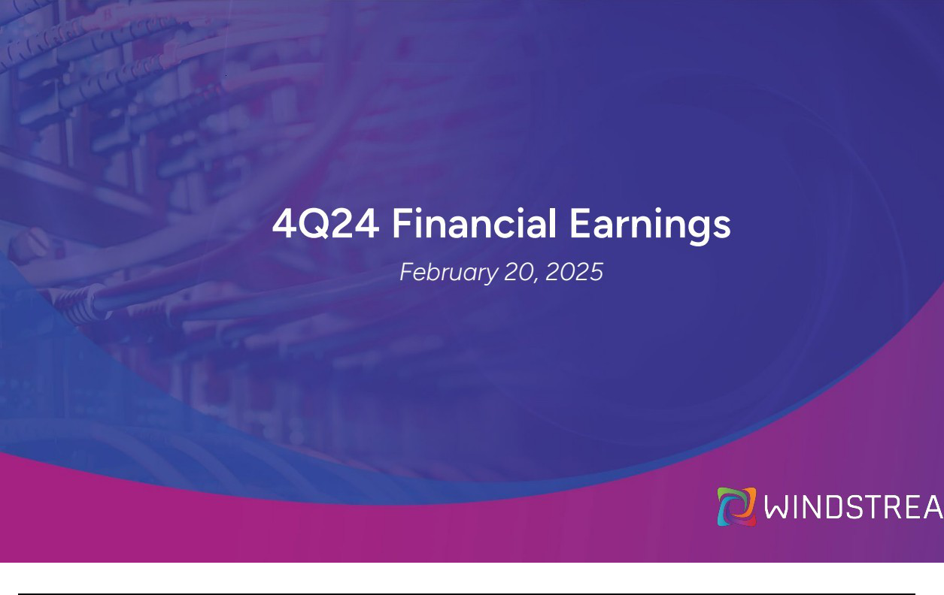

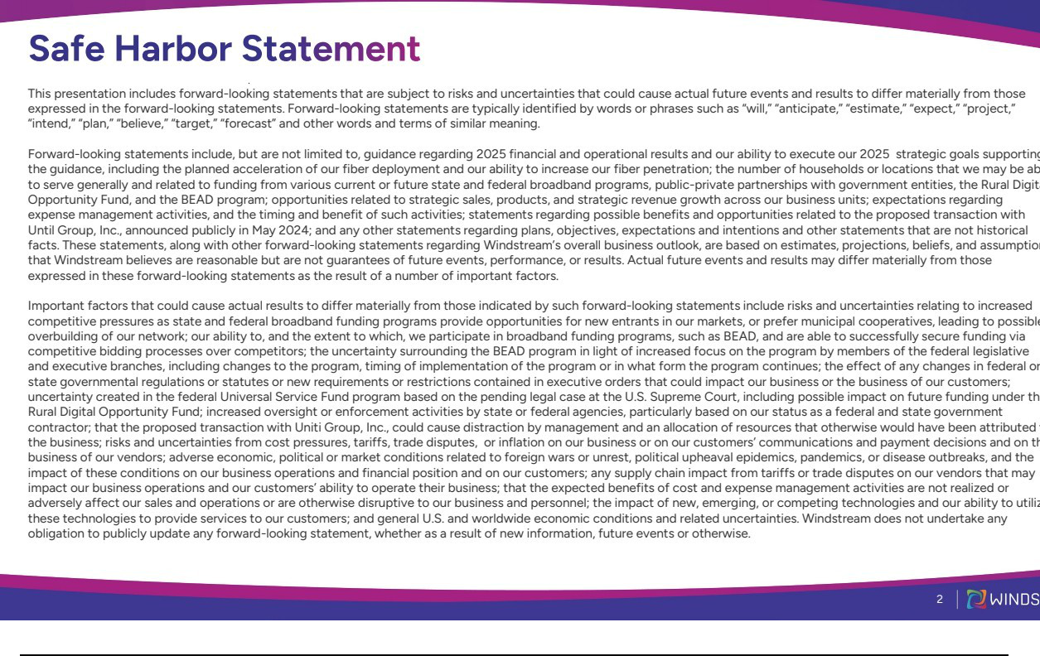

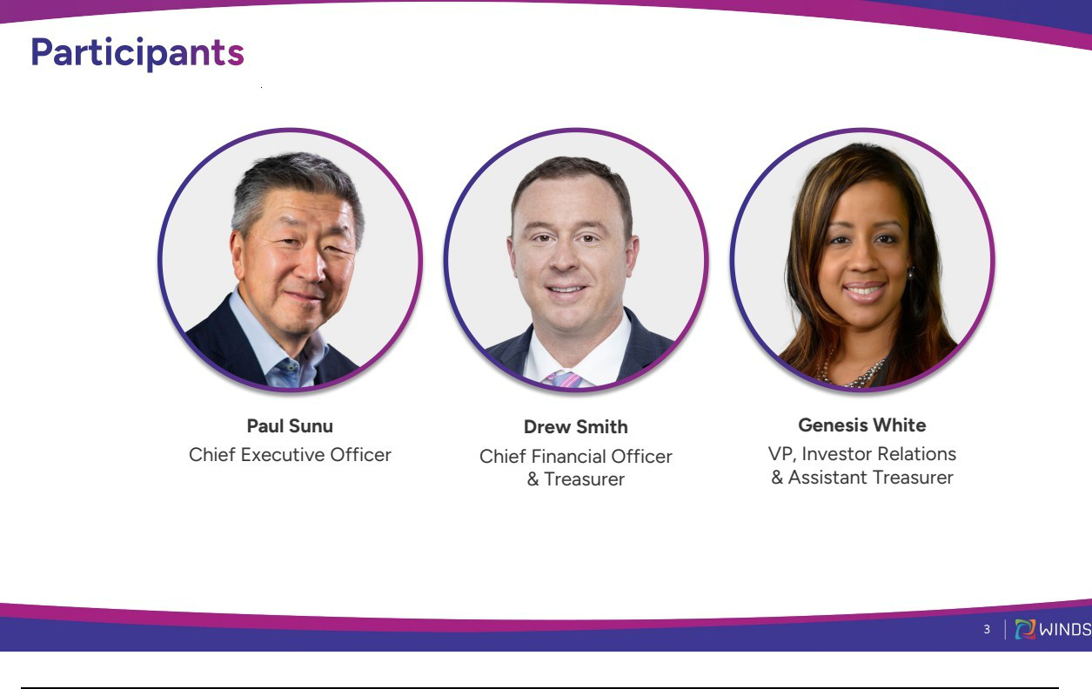

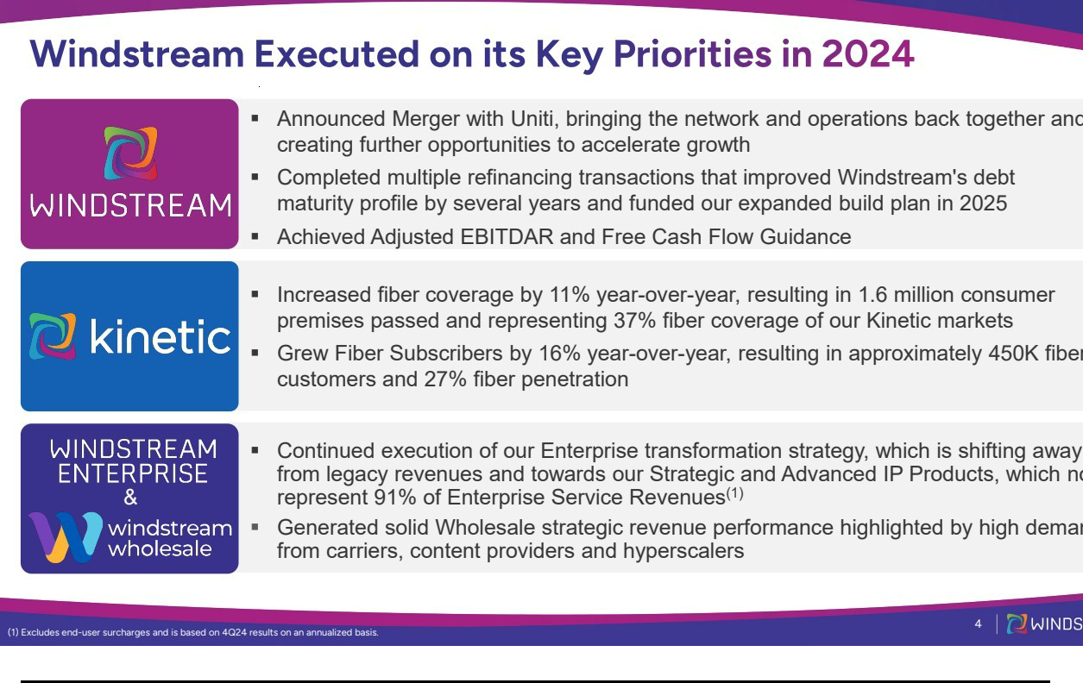

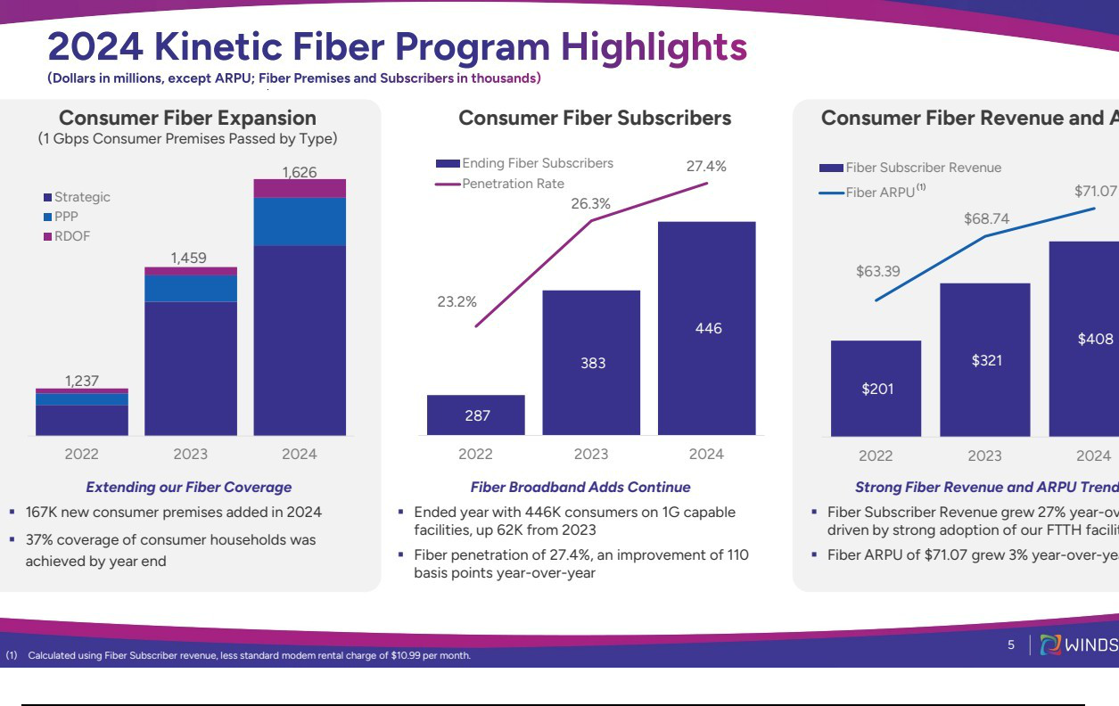

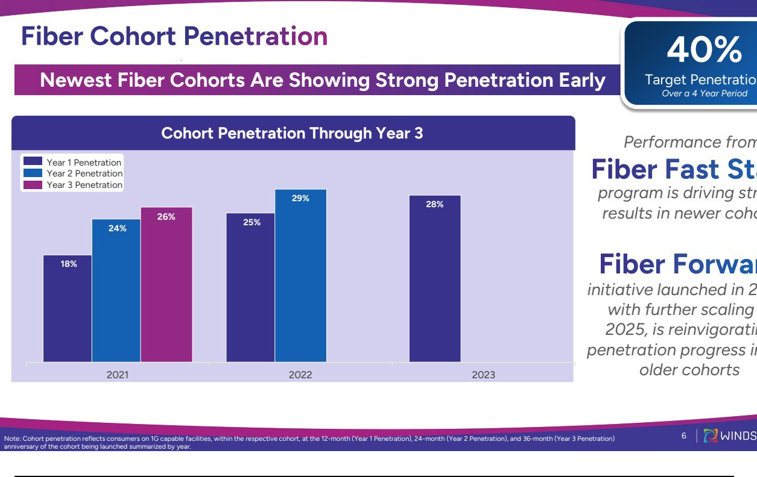

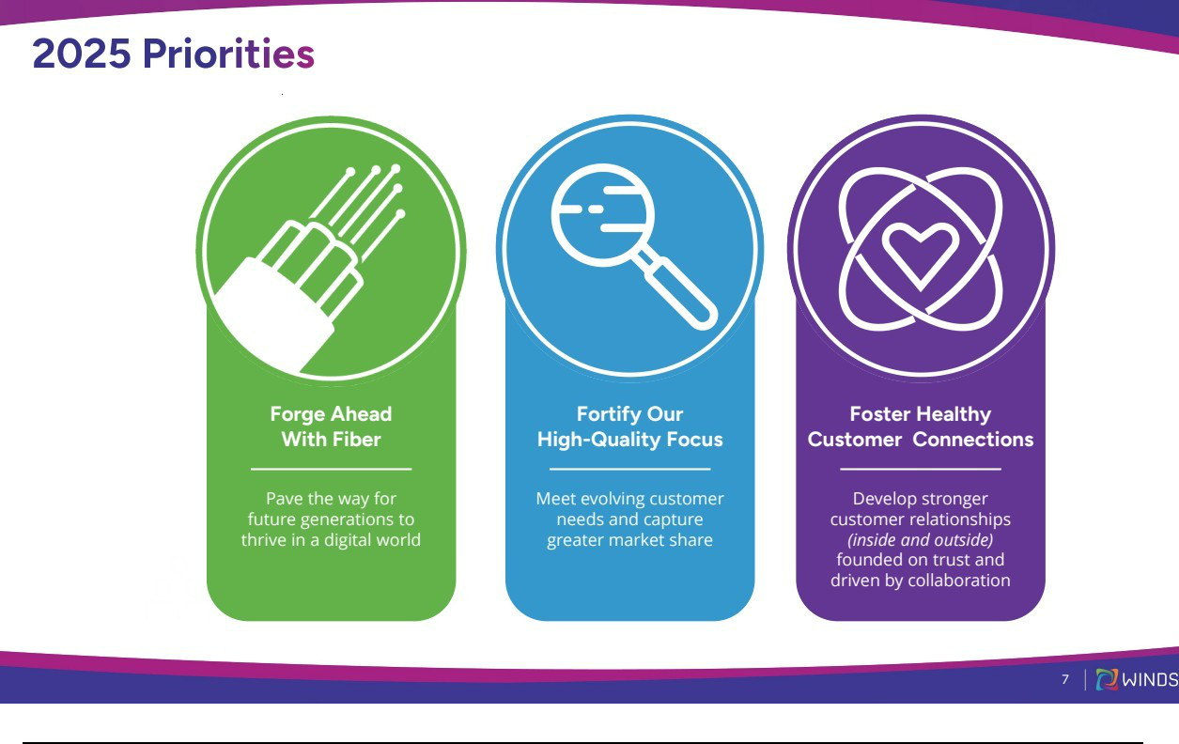

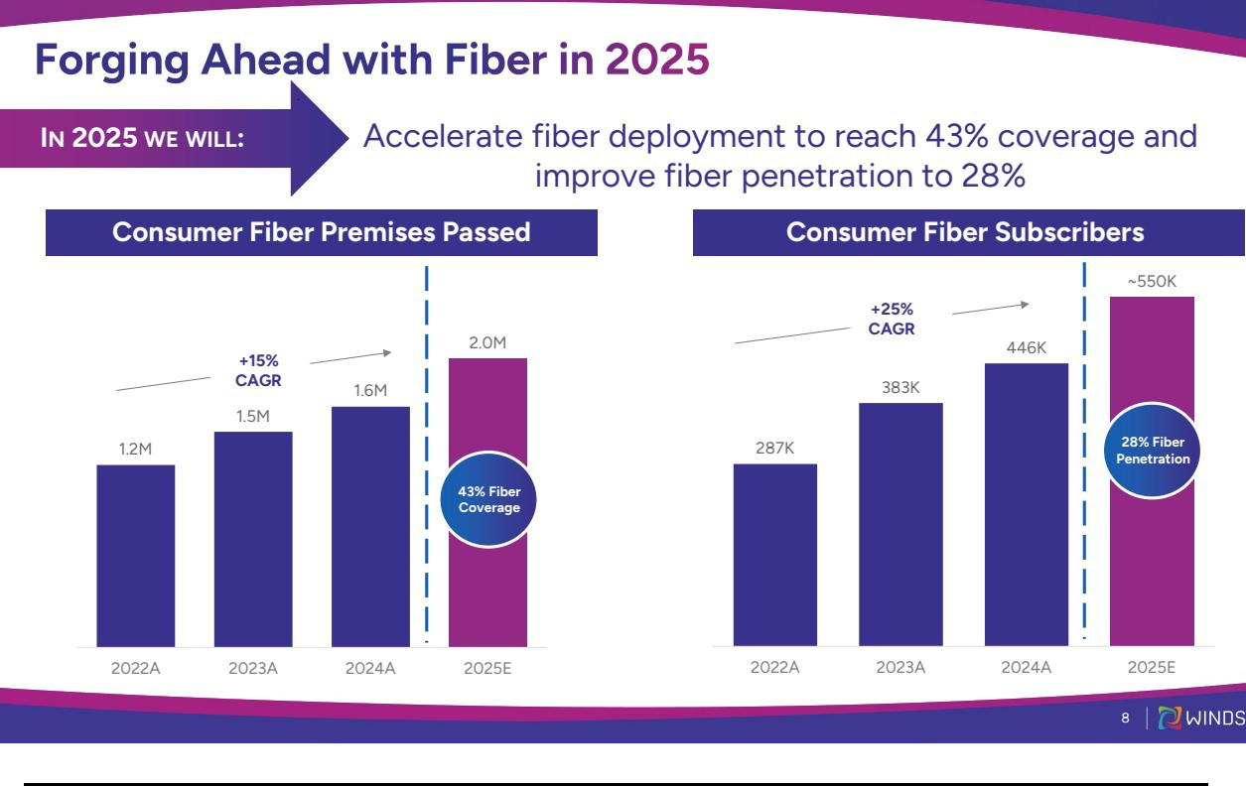

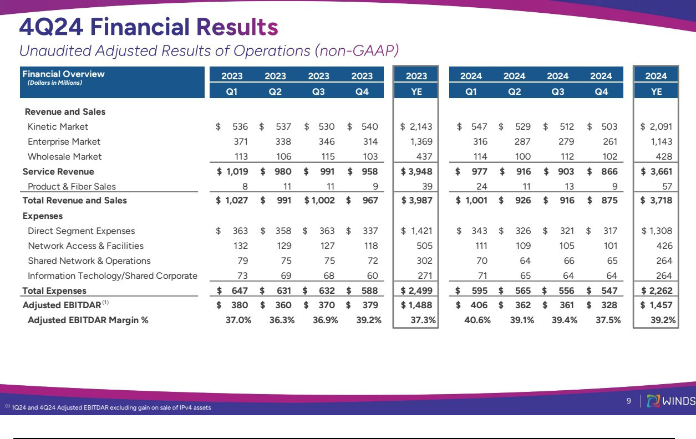

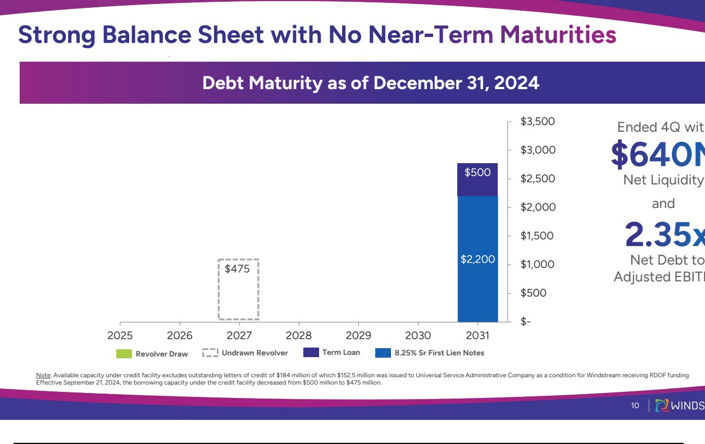

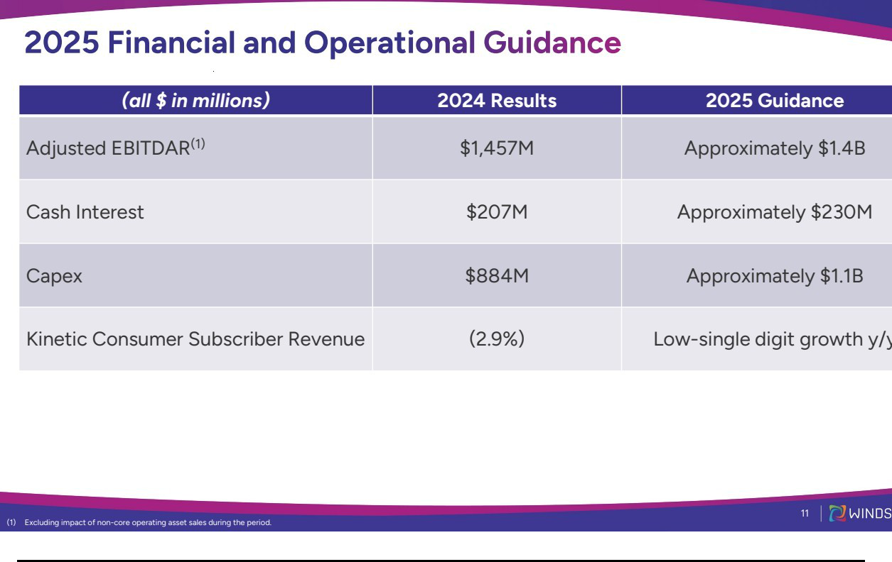

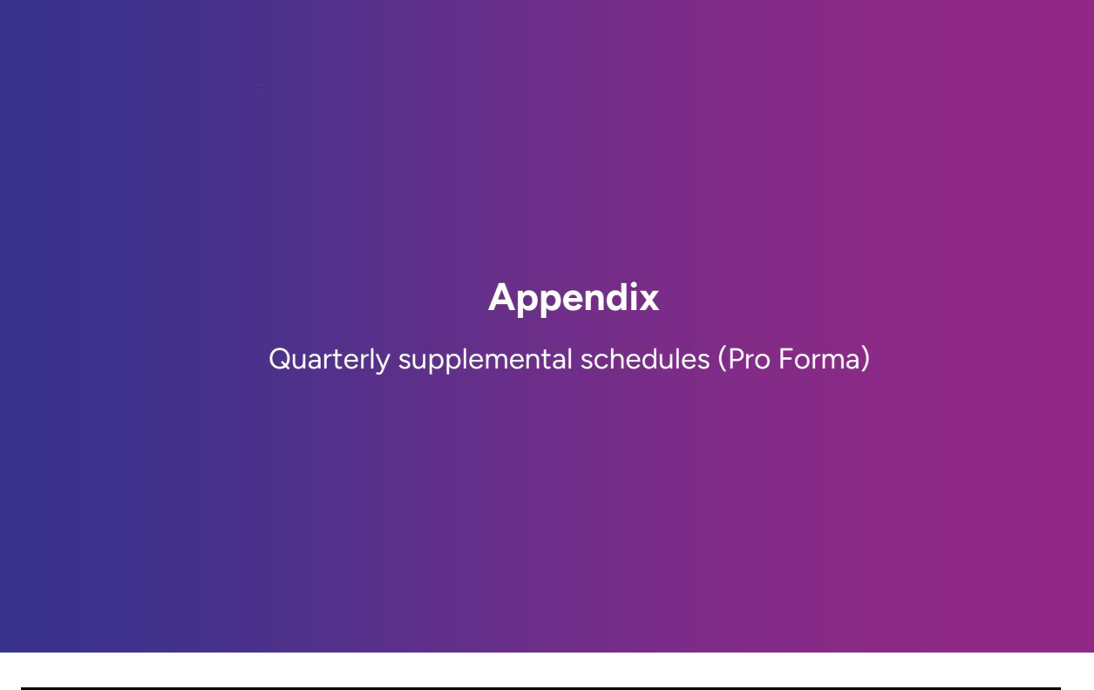

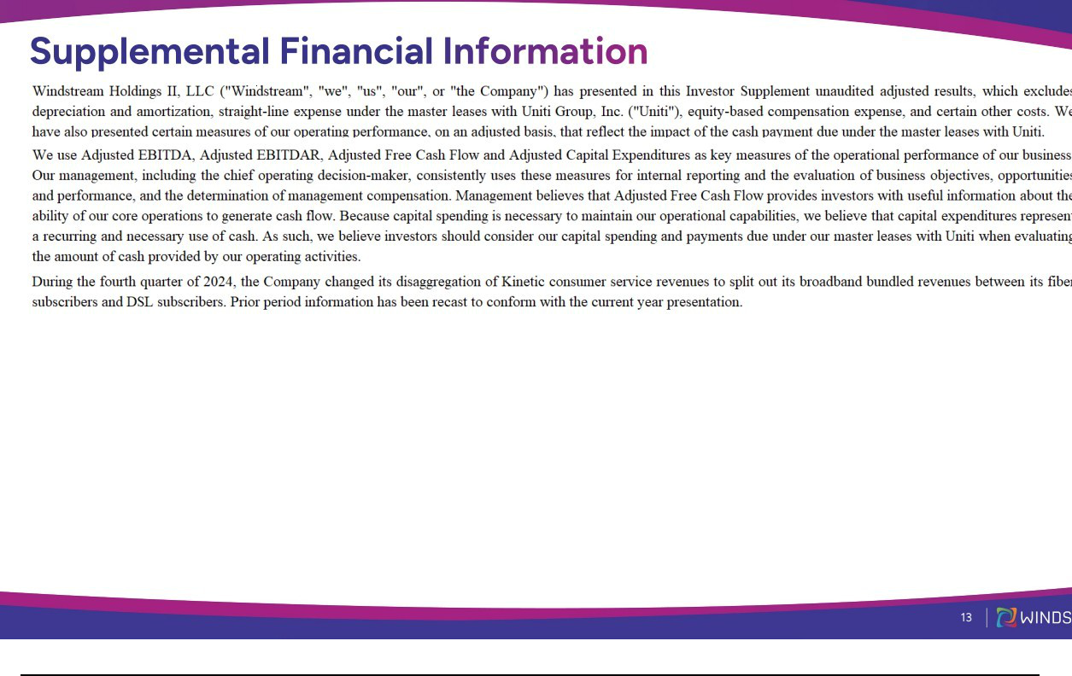

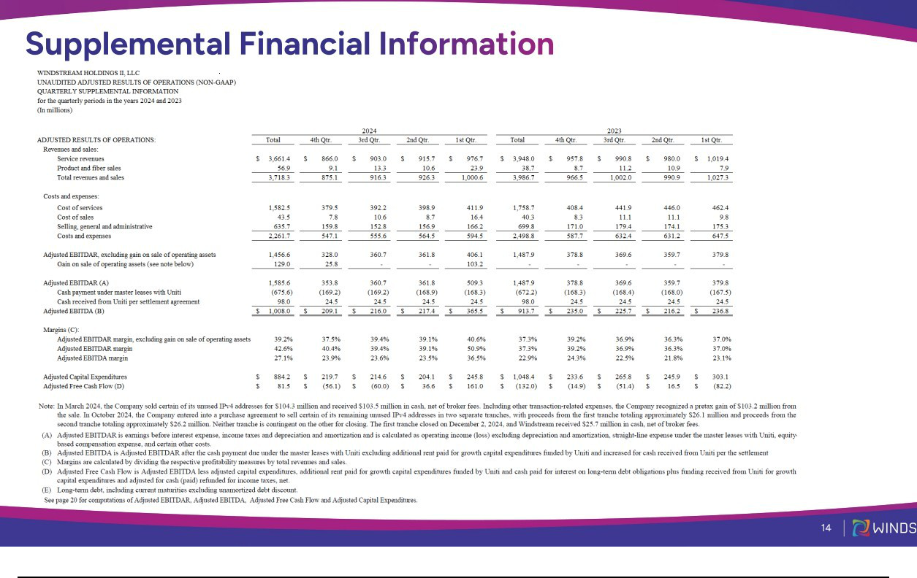

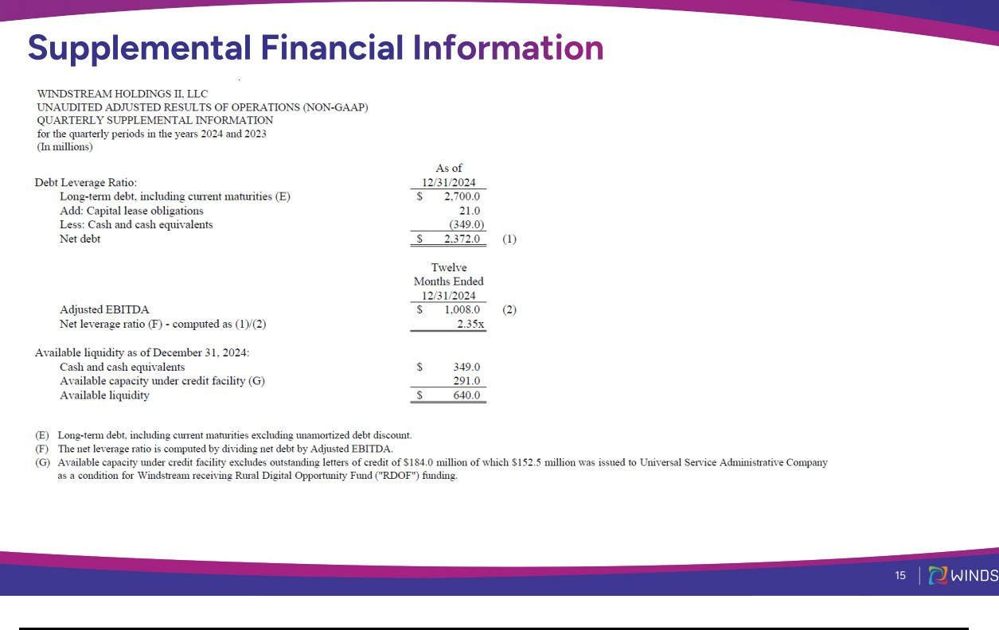

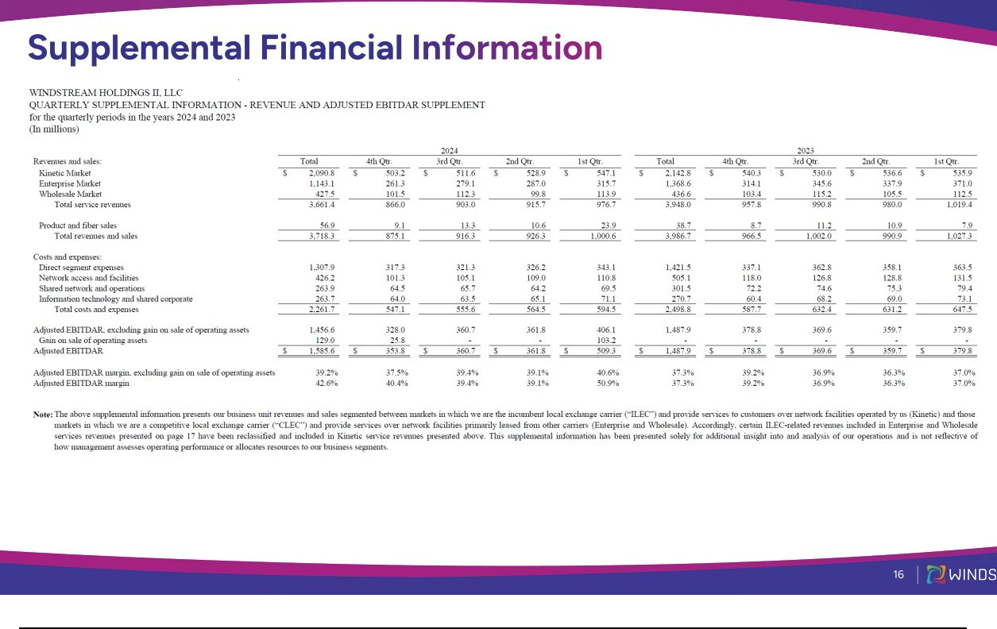

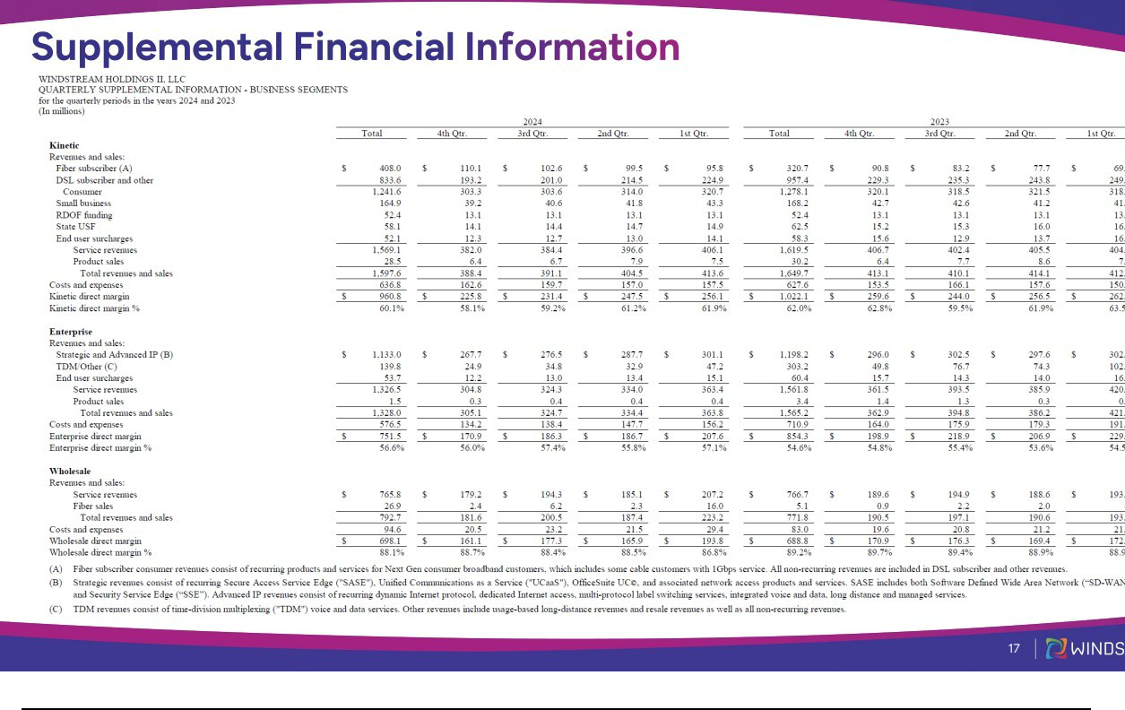

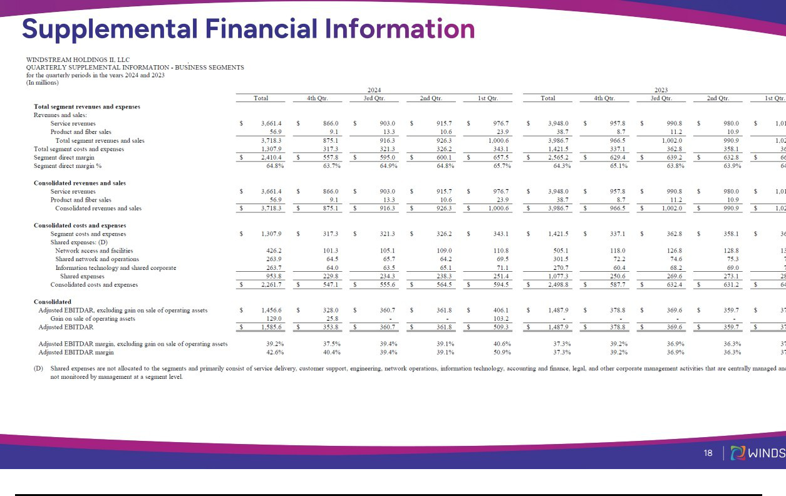

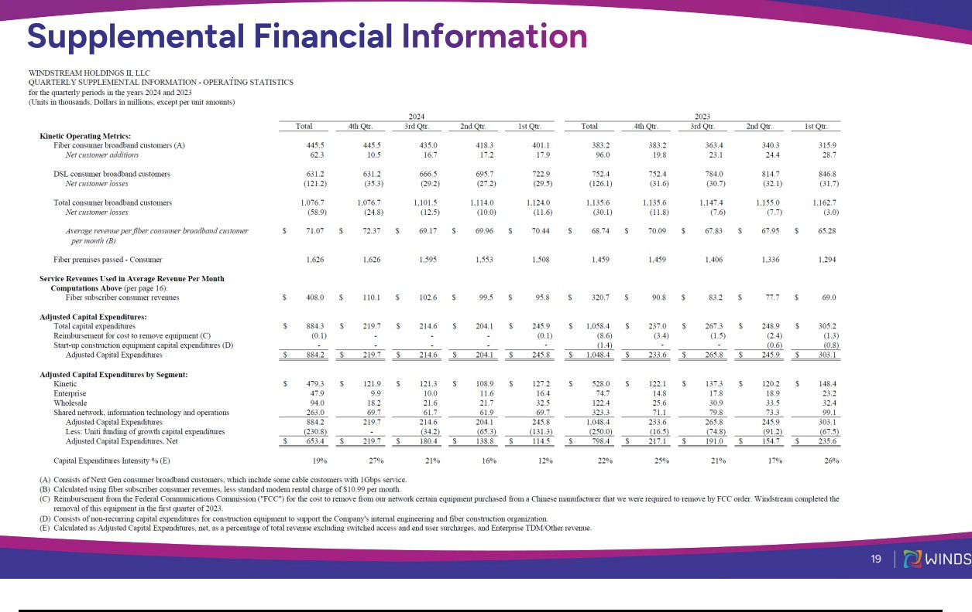

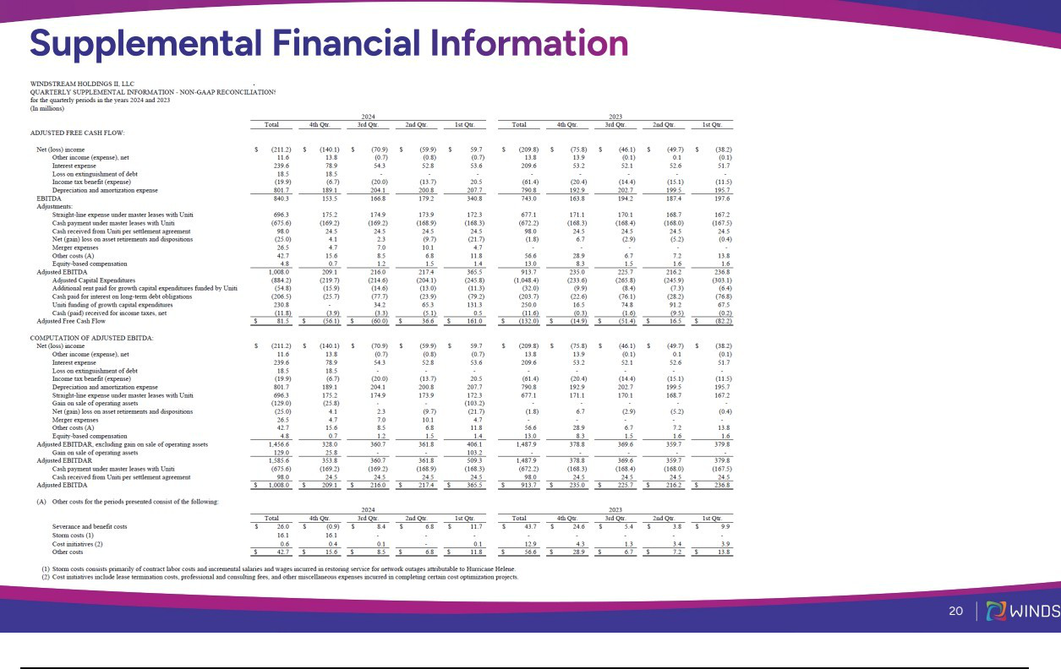

Exhibit 99.3

Windstream 4Q24 Earnings Call – Prepared Remarks

February 20, 2025

Genesis White

Good morning everyone and thank you for joining Windstream’s fourth quarter 2024 earnings conference call.

Joining me on the call today are:

- Paul Sunu, our CEO, and

- Drew Smith, our CFO and Treasurer

To accompany today’s call, we have posted the presentation slides and supplemental schedule on our various investor websites. If you do not have access to these websites, please reach out to me at Genesis dot White at windstream dot com.

Our financial statements, prepared in accordance with U.S. GAAP, will be available by mid- March to our lenders and investors, in compliance with the terms of the Credit Agreement, Indenture, and Amended and Restated LLC Agreement.

Today’s discussion includes statements about expected future events and financial results that are forward-looking and subject to risks and uncertainties and the disclosure to our forward-looking statements will be contained in our financial statements. Let me now turn it over to Paul Sunu.

Paul Sunu

Good morning and thank you for joining us.

Today, we are pleased to share with you our 2024 results, which showed solid financial and operational performance across our business.

In 2024 we embraced and instilled quality into every element of our operations from construction to installation to repair and care.

And through it we brought greater customer satisfaction and increased operational productivity while seeing meaningful reductions in churn and call center volumes.

Further, in advance of accelerating and expanding our fiber builds, we elevated the skills of our technicians, and local managers, and promoted a culture of assuring quality with every installation and every repair.

With that, allow me to share a few highlights of our full year results.

As seen on Slide 4, Windstream executed on its key priorities in 2024.

We enhanced our strategic profile by bringing our network back with our operations through the announced merger with Uniti.

Further, through multiple refinancing transactions, we improved our debt maturity profile and added the required liquidity to fully fund our enhanced build plan for 2025.

And through operational effectiveness we achieved our strategic priorities and financial guidance for the year.

Within Kinetic, we increased our fiber coverage and grew our fiber subscribers year-over-year, highlighting our continued commitment to extending our fiber footprint within Kinetic’s markets.

Enterprise and Wholesale continued their solid performance.

Inside Enterprise, our Strategic and Advanced IP portfolio revenues reached 91% of our total Enterprise Market service revenues on an annualized basis, excluding end-user surcharges.

Windstream Wholesale continues to demonstrate its market leadership in innovation with the first ever 800G transatlantic connection. Furthermore, Wholesale’s core fiber transport service continues to resonate with carriers, content providers and hyperscalers.

Slide 5 provides a bit more insight into Kinetic’s Fiber performance for the year.

We extended our fiber coverage by passing an additional 167,000 consumer premises during the year, or growth of 11% year-over-year, bringing our total to over 1.6 million consumer premises passed or 37% of Kinetic’s footprint.

While we made great strides in extending our fiber reach during the year, we experienced an unusual series of devasting natural disasters in our service territories—including tornados, wildfires and back-to-back Hurricanes.

These events required us to redirect resources towards recovery and restoration efforts in the back half of the year, impacting operational trends in the fourth quarter.

Our priority is the safe and complete restoral of services for our customers and the communities we serve.

And so, I am happy to say that we have substantially completed all restoration and clean-up efforts, and the team is now poised and sharply focused on executing on our 2025 priorities.

Now let’s take a look at our fiber subscriber growth.

Despite a slow-down in the fourth quarter from the impact of the afore-mentioned storms, our fiber subscribers grew 16% year-over-year and fiber subscriber revenue grew 27% for the same period, demonstrating strong adoption of our fiber product.

We ended the year with approximately 450,000 subscribers on our fiber network, representing a 27.4% penetration rate, an improvement of 110 basis points year-over-year.

Additionally, you can see the performance of our Fiber Fast Start initiative on Slide 6, as our latest cohorts continue to show impressive penetration results.

Furthermore, we launched our Fiber Forward initiative during the second quarter, which leverages the tactics and learning from Fiber Fast Start to reinvigorate our older cohorts. While this program is still ramping, we are seeing encouraging improvements in the markets launched, including as much as a 50% increase in sales.

These indicators are a positive sign, and to further drive penetration in our older cohorts, we intend to apply this initiative to nearly three times the number of households in 2025.

Overall, I am quite pleased with our performance in 2024.

We demonstrated continued momentum across our strategic initiatives, as well as operational improvements generated from our quality focus, all of which serves as a solid platform for executing on our 2025 initiatives.

Now, slide 7 shows our 2025 priorities.

We plan to build more fiber to meet the growing demands in our residential, business, and wholesale markets.

Looking at slide 8, our plan is to nearly double the rate of our fiber builds in 2025, compared to what was completed last year.

This will result in about 2 million consumer premises passed, or 43% coverage of our Kinetic footprint, by the end of this year.

The ramp in our internal construction hiring, the increased training and adherence to our quality standards, along with the additional funding from our recent refinancing activities, all contribute to facilitating the execution of our 2025 vision to accelerate fiber deployment.

In addition, through the demonstrated successes of our fiber fast start and fiber forward initiatives, we expect to drive increased penetration in our fiber markets.

Additionally, we want to more effectively mine the high-margin, on-net businesses in our Kinetic markets.

We believe that utilizing the go to market expertise, as well as the products and services, of our Enterprise team can generate the momentum for growth in this area.

At the same time, we have entrusted the care of our valuable base of Enterprise customers to a select team of skilled professionals.

And finally, before we get to our financial results, let me address the progress on our planned merger with Uniti.

We have now received sixteen state approvals and have two state approvals in process.

In addition, the SEC completed its review of the Form S-4 earlier this month and the Registration Statement has now been declared effective.

We defer to Uniti management on specifics of the transaction and next steps in the closing process.

We still expect the merger to close in the second half of 2025, subject to customary closing conditions, including receipt of regulatory and Uniti shareholder approvals.

In the meantime, we remain steadfast in executing on our 2025 priorities, delivering high-quality service to our customers and driving growth.

With that, let me turn the call over to Drew to cover our financial highlights for the quarter, as well as our 2025 financial and operational guidance.

Drew Smith

Thank you, Paul, and good morning everyone.

First, I wanted to take time to highlight our recent financing transactions. Earlier in the quarter, we completed the issuance of $800 million in senior first lien notes, as well as a new $500 million incremental term loan, both of which mature in 2031. Proceeds from these issuances were used to repay our existing Term Loans, as well as adding additional liquidity of over $300 million. We intend to use this incremental liquidity for the expansion and acceleration of our Kinetic fiber-to-the-home buildout, which Paul walked through earlier.

Later in the quarter, we completed an additional refinancing transaction that included a $1.4 billion add-on to the recently issued 2031 senior first lien notes. This refinancing resulted in the redemption of our existing 2028 senior first lien notes, which allowed for meaningful maturity extension while remaining leverage neutral. With the successful completion of these transactions, Windstream now has no debt maturities for over six years.

Turning to Slide 9, we show our fourth quarter financial results.

During the quarter, Windstream generated:

- Total revenues of $875 million, and

- Adjusted EBITDAR of $328 million, which was down 13% year-over-year due to declining Enterprise & Wholesale legacy margins, as well as lower Kinetic margins primarily driven by impact from the ACP funding elimination.

Moving to our market-level business revenue trends:

Within Kinetic:

  - Service revenue was $503 million, which was down 6.9% year-over-year, with consumer service revenue down 5.2% year-over-year, driven largely by the ACP funding step-downs.

  - Kinetic fiber subscriber revenue was up 21% year-over-year, and fiber ARPU of $72.37 was up 3% year-over-year.

  - Fiber consumer broadband subscribers grew by 10,500 during the quarter. This was offset by a loss of 35,300 DSL customers, resulting in a net decrease in total broadband units of 24,800 for the quarter. Within Enterprise:

- Service revenue was $261 million, down 17%, as legacy-TDM revenues continue to see ongoing declines as expected.

- Notably, approximately 91% of Enterprise Market service revenues, excluding end-user surcharges, came from our Strategic and Advanced IP portfolios. These combined revenues were down 5% for the full year.

- TDM and Other revenue declined 50% year-over-year as we continue to execute our TDM exit strategy

Within Wholesale:

- Service revenue was $102 million, down 1.8% year-over-year, driven by declines in legacy revenues. Strategic revenues had solid performance during the quarter highlighted by high demand being seen from carriers, content providers and hyperscalers.

Turning to expenses:

- Total cash expenses during the fourth quarter fell by over $40 million, or approximately 7%, year-over-year, driven by our interconnection expense reduction activities, as well as our quality and unification efforts across the company. Cash expenses fell by almost $240 million in 2024 over 2023 levels.

- Notably, our interconnection and network facility expenses fell by 15% year-over-year on an annualized basis as we continue our TDM exit plan, which we expect to complete this year.

Transitioning to slide 10, Windstream has a strong balance sheet, and following the refinancing transactions discussed earlier, we have no current debt maturities until 2031. Overall, these transactions put us in a great position as it relates to the combined capital structure with Uniti post- merger close, while also providing opportunities for us to fund our expanded fiber build plan in 2025. As of December 31st, we ended with $640 million in total liquidity and a net debt to adjusted EBITDA ratio of 2.35x.

On slide 11, we introduce our 2025 financial and operational guidance, which includes:

- Adjusted EBITDAR, of approximately $1.4 billion; and

- Cash interest of approximately $230 million following our recent refinancing transactions

- Capital expenditures will step-up to approximately $1.1 billion, reflecting the impact of our accelerated and expanded fiber build program; and finally,

- We expect low-single digit growth in Kinetic consumer subscriber revenue

Now, I will turn the call back over to Paul for some closing comments.

Paul Sunu

Thank you, Drew.

In closing, Windstream delivered solid financial and operational results across our business during 2024.

We continue to extend our fiber footprint within our Kinetic markets.

And in 2025 we plan to build on the foundation of quality we created last year by accelerating our fiber builds and propelling our fiber penetration.

With that, we can now open the call up for questions.

